TEAMS 5.8.1|Release Date 01.24.2022

EXCEPTION ERROR PREVENTING CREATION OF PROFILE FOR SOME PARTICIPANTS

Purpose
A fix was made for exception error happening when creating a profile for the participants who have received an HSE from TEA with an issue date that falls in current program year.

UPDATE TRAINING SERVICE COLUMN HEADER

Purpose
Updated Training Service Detail by adding “Training Service Name”

Prototype Screen – Training Services
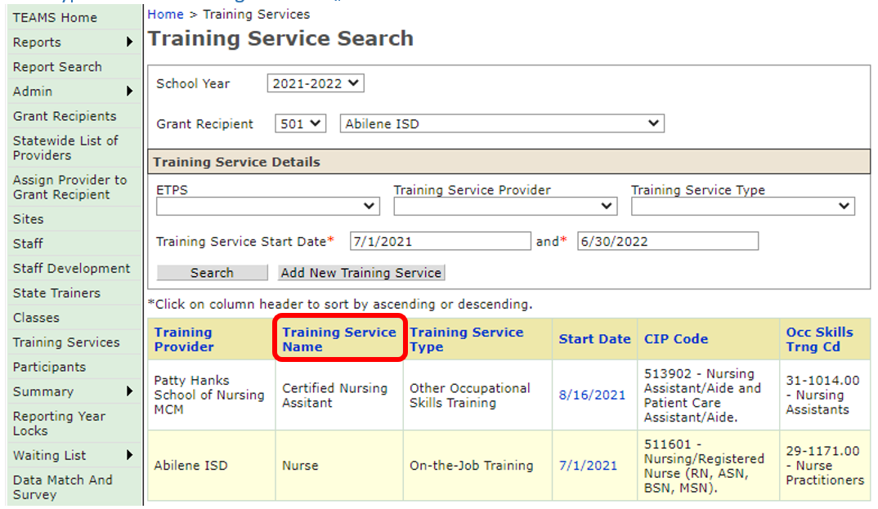

REMOVED “INFORMATION RELEASE” FIELD ON PARTICIPANT PAGE

Purpose
The Privacy section which includes “Do Not Release Directory Information” has been removed from the add new participant page. All participants must acknowledge the sharing of their information for purposes of reporting by TWC with partners as outlined in the AEL Guide as a condition of enrollment.

Prototype Screen - Will Be Removed
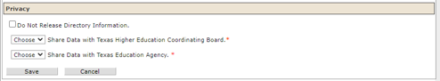

FIXED CONTACT HOURS EXCEPTION ERROR

Purpose
Programs were reporting an exception error preventing data entry of contact hours. Fix has been made.

STAFF DEVELOPMENT/QUALIFICATION UPDATED

Purpose
TEAMS was allowing users with Director level access to approve their own staff exemptions. Per TWC guidance, the approval of both professional development and educational requirement exceptions must be approved by the state. Director role access can only view Exception Type: Staff Development and Minimum Qualification for staff.

