TEAMS 5.9|Release Date 09.16.2022

REMOVED TYPE 1b MSG ENTERED PRIOR TO POP LAST SERVICE DATE

Purpose
Data fix to remove Measurable Skills Gain (MSG)/Post-Secondary Education (PSE) (Type 1b MSG) from participants that have been entered prior to their last Period of Participation (POP) Last Service Date. This data fix should validate ALL PSE MSGs.

Business Rules
Data fix must delete ALL PSE/MSGs that do not meet the conditions in Batch Processing Updates.

Batch Processing Updates
Remove the MSG/PSE when the following conditions are NOT met:
- The Last Service Date is in the Program Year that the student has a profile for.
- AND the Date Achieved is in the Program Year that the student has a profile for.
- AND the Start Date/Date Achieved is > then the Last Service Date
Note: If there is more than one POP in the PY, then Date Achieved must be > Last Service Date of any POP within the PY. Exit Date should be in the same PY as Last Service Date and Achieved Date.

Note1: It is possible for an MSG/PSE Date Achieved to be within an open POP if there exists a previous POP whose Last Service Date is within the PY that the Date Achieved is in.

Note2: Do Not delete any of the corresponding EE/PSEs.

ADD GED ID AND GED CERTIFICATE ID TO PARTICIPANT SEARCH PAGE

Purpose
Users can search Participant by entering GED ID and Certificate ID in place of three criteria searching and along with Participant ID, SSN, Driver’s License/State ID Number, Identity Document Number, or Other Document Number search.

Prototype Screen – Home > Participant
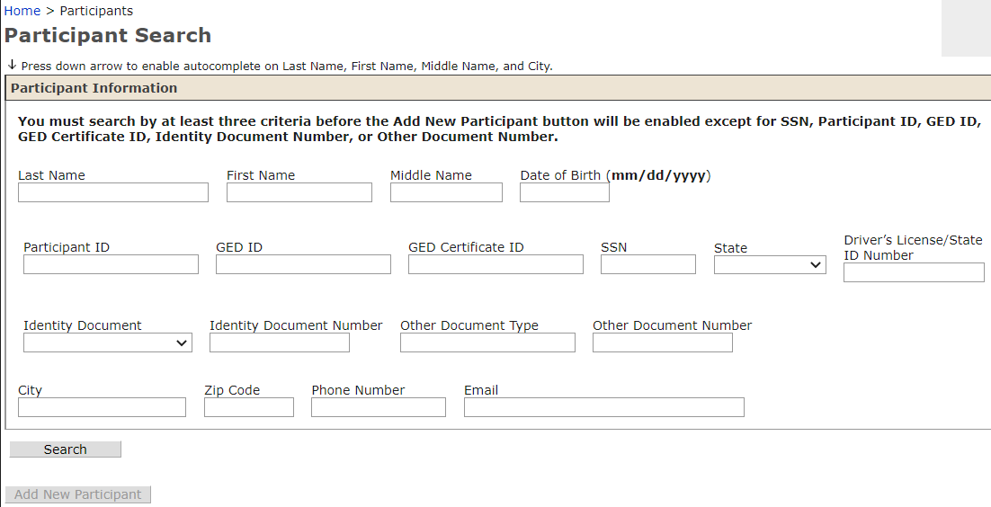

Prototype Screen – Home > Participant > Enter GED ID > Search
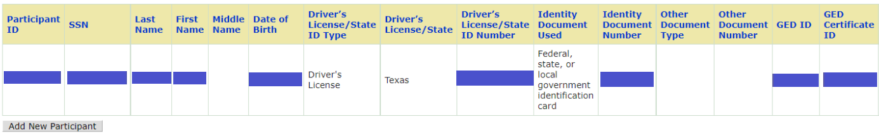

MODIFY SUPPORT SERVICES PAGE – UPDATE HSE DETAILS

Purpose
Modification to Support Services Details page consist of adding new drop-down options for users when entering an HSE Voucher Code. This enhancement will also remove the five HSE Voucher code limit for participants and include a no monetary limit as well.

Modification to Support Services Page consist of new columns to display information from the changes in the Support Services Details Page. The new columns are “Test Type”, “Test Subject”, “Test Format”, and “Voucher Amount”.

Prototype Screen – Home > Participant > Participant Name > Support Services > Support Service Details
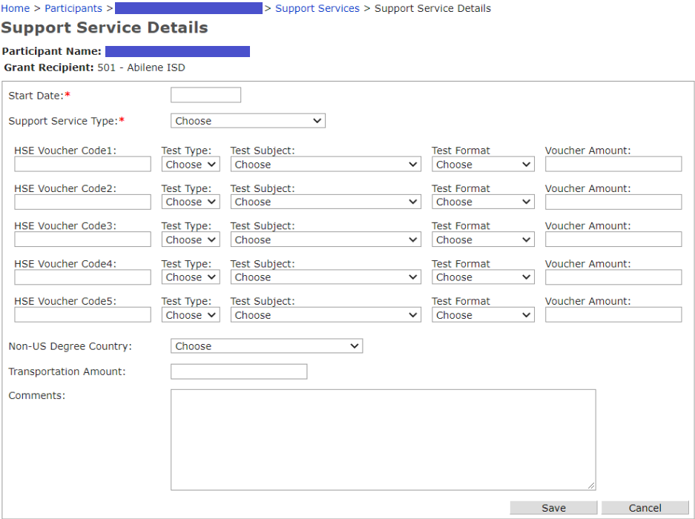

Prototype Screen – Home > Participant > Participant Name > Support Services

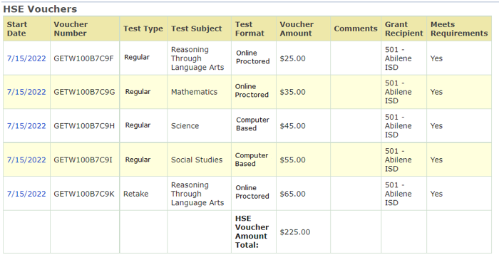

Business Rules
Support Service Details Page

1.1 Add drop down box labeled “Test Type,” options include:
    - Retake
    - Regular

1.2 Add drop down box labeled “Test Format,” options include:
    - Online Proctored
    - Computer Based

1.3 Add drop down box labeled “Test Subject,” options include:
    - Reasoning Through Language Arts
    - Mathematics
    - Science
    - Social Studies

1.4 Add drop down box labeled “Voucher Amount,”: Allow user to enter only numerical dollar amount.

Drop down box will be displayed for each corresponding “HSE Voucher Code (1-5)” field box per prototype Support Service Details Page.

1.5 If User does NOT select HSE Voucher from “Support Service Type” box:
    - Disable “Test Type”, “Test Format”, “Test Subject”, and “Voucher Amount”
    - Do not allow user to select options from “Test Type”, “Test Format”, and “Test Subject” drop down box
    - Do not allow user to enter values in “Voucher Amount” text box

1.6 Update Transportation criteria “Amount” label to “Transportation Amount”

1.7 If User selects HSE Voucher from “Support Service Type” box:
AND “Start Date” field is >= 07/01/2022:
AND user does not enter a dollar amount for “Voucher Amount”: when clicking Save: Display error message:
“HSE Voucher Amount is Required”

1.8 If User select HSE Voucher “Support Service Type” box:
AND “Start Date” field is >= 07/01/2022:
AND user does not select an option for “Test Type:” when clicking Save:
Display error message:
“Test Type is Required”

1.9 If User select HSE Voucher “Support Service Type” box:
AND “Start Date” field is >= 07/01/2022:
AND user does not select an option for “Test Format:” when clicking Save:
Display error message:
“Test Format is Required”

1.10 If User select HSE Voucher “Support Service Type” box:
AND “Start Date” field is >= 07/01/2022:
AND user does not select an option for “Test Subject:” when clicking Save:
Display error message:
“Test Subject is Required”

1.11 Remove the 5 HSE Voucher limit on participants and allow users to re-submit more HSE Vouchers for participants. There will be no monetary limit for HSE Vouchers.

1.12 If User select HSE Voucher “Support Service Type” box:
AND “Start Date” field is >= 07/01/2022:
HSE Voucher Codes 1 is required along with all new added fields:
    - Test Type
    - Test Subject
    - Test Format
    - Voucher Amount
In order to allow User to successfully Save HSE Voucher detail record.

ELSE IF User selects HSE Voucher from “Support Service Type” box:
AND “Start Date” field is <=07/01/2022:
HSE Voucher Code 1 is required BUT NONE of the new fields are required.
User is allowed to Enter and Save any of the new field if possible.

ELSE IF User attempts to enter one of the new fields without entering Voucher Code 1, Display Error Message:
“HSE Voucher Code is required to enter the other HSE Voucher-Related fields”

Note: This rule applies for both “Start Date” conditions. The above rule applies if User provides HSE Voucher 2 thru 5.

Support Service Page

2.1 Add Test Type column to Support Service Page.

2.2 Add Test Format column to Support Service Page.

2.3 Add Test Subject column to Support Service Page.

2.4 Add Voucher Amount column to Support Service Page.

2.5 Add HSE Voucher Amount Total section to Support Service Page.

SUPPORT SERVICES/HSE VOUCHER ENTRY FOR NON-AEL STUDENTS

Purpose
Data fix to correct exception error when entering Support Services/HSE Voucher for Non-AEL Student. Non-AEL student must be entered in TEAMS and does not need a PIRL/Profile.

Prototype Screen – Home > Participant > Participant Name > Support Services > Add Support Service > Support Service Details

ADMIN MEMO PAGE

Purpose
Admin Memo page is up and working. AEL TEAMS Technical Assistance will be able to provide up-to-date notifications. User should check this page for most recent release or statewide technical issues.

Prototype Screen – Home > Admin Memo
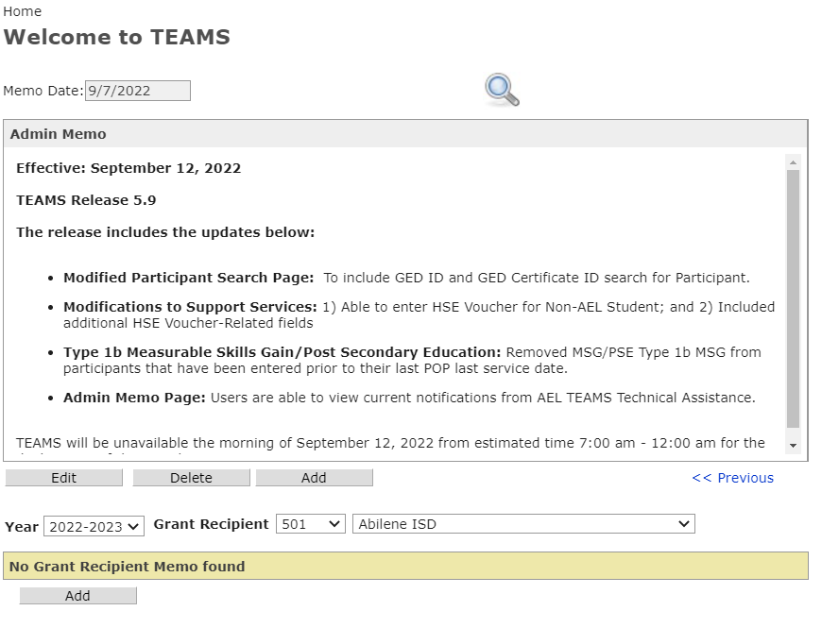

STAFF DEVELOPMENT PRE/IN SERVICE HOURS (REMOVED PRE)

Purpose
Removed “Pre” Staff Development for In Service Hours.

Prototype Screen – Home > Staff Development > Staff Development Activities Search
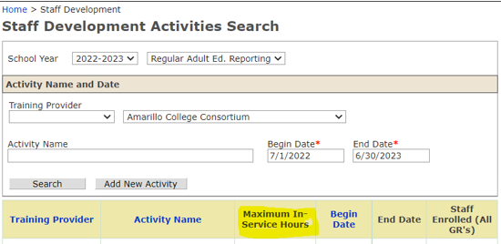

Prototype Screen – Home > Staff Development > Staff Development Activities Search > Add New Activity
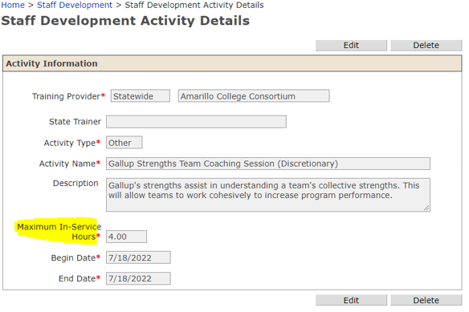

Prototype Screen – Home > Staff Development > Staff Development Activities Details > Add Staff

