TEAMS 5.6|Release Date 03.19.2021

DISABLE THE “ADD NEW PARTICPANT” BUTTON UNTIL SEARCH IS CONDUCTED

Purpose
Users creating duplicate participant records has been an ongoing problem in TEAMS and has come up in the Texas Workforce Commission internal audits. To address this problem, we’ve created a three-pronged approach.
- Disable the “Add as New Participant” button until the user has done a search Using First/Last Name and Date of Birth (DOB).
- Data fix to merge as many of the participant records as we can up front.
- Add a merge participant records feature to TEAMS.
This change may require some training and procedural changes locally to ensure when staff are looking up students in TEAMS, they have their DOB, Participant ID, or Other Document Number available.

New Profile Elements
The add New Participant button has been disabled until search is complete. The participant search results has been revamped to include additional student identifiers to help determine the best selection of existing students in the system.

If you do not know the student’s Date of Birth (DOB), but they have indicated being in your program previously, you can utilize the period of participation (POP) report to get this information.

Home> Participant > Participant Search
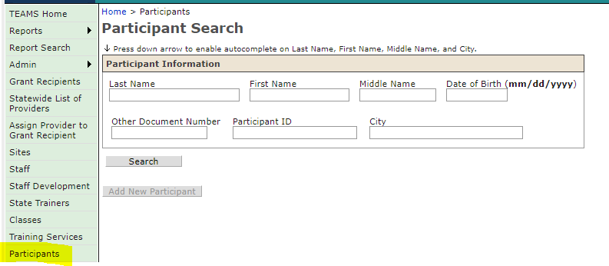

Business Rules
We modified the following fields below to the ‘Participant Search’ in the following order.

- Participant must search combination of required elements to generate a response. If the user tries to search for a participant in any combination other than those listed below, user will receive notification “(You must search by Last Name + First Name + Date of Birth together or Participant ID or Other Document Number. Middle Initial and City are optional search criteria)”. In essence, the user can search by the following combinations:
  - Last Name + First Name + Date of Birth
    - Optional: Middle Initial and/or City
  - Or, Participant ID
    - Optional: Middle Initial and/or City
  - Or, Other Document Number
    - Optional: Middle Initial and/or City

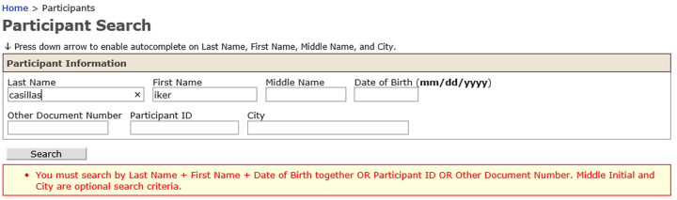

- Display the search results below in ascending order by Last Name, First Name, Date of Birth, and City below the following read-only columns.
  - Participant ID
  - SSN
  - Last Name
  - First Name
  - Middle Name
  - Date of Birth
  - Driver’s License/State ID Type
  - Driver’s License/State ID Number
  - Identity Document Used
  - Identity Document Number
  - Other Document Type
  - Other Document Number
  - Street Address
  - City, State, Zip Code
  - Merged

- Prior to this fix, if there is only one participant match, TEAMS would automatically open the Participant page for that participant. With the edit, you will still have to select the participant to take you to the participant’s page.

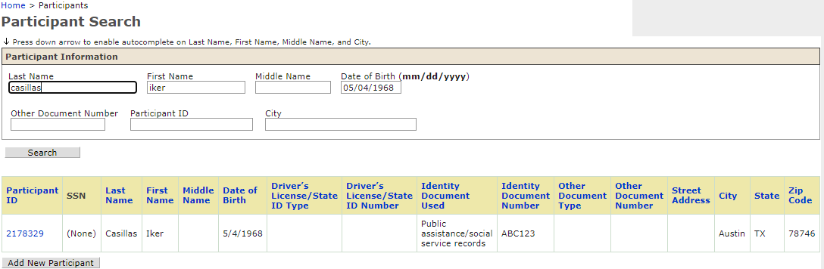

- If the user determines that none of the search results match his/her participant, allow the user to click on the Add New Participant button. When the Add New Participant button is clicked on, display the message, “After performing a search, I certify that this is a new participant that does not already exist in TEAMS” and allow the user to select the OK button or the Cancel button.

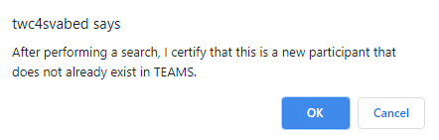

- Participant Already Exist With Same Information
  - User will receive the following message to include (Participant ID, Last Name, First Name), “Another participant is already registered with this SSN (Participant ID, Last Name, First Name)”.
    - This message is an edit that prevents a save.
    - This message is only displayed when the user is attempting to save a new or modified SSN.

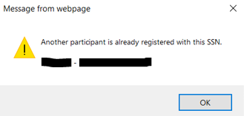
  - If the user tries to save a participant record with a Driver’s License or State ID with the same State and Number as an existing participant record, display the message, “Another participant is already registered with this Driver’s License/State ID and Number. (Participant ID, Last Name, First Name)”.
    - This message is an edit that prevents a save.
    - This message is only displayed when the user is attempting to save a new or modified Driver’s License/State ID and Number.

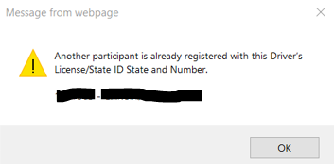

  - If the user tries to save a participant record with the same Last Name + First Name + Date of Birth as an existing participant record, display the message “Another participant is already registered with this Last Name + First Name + Date of Birth. (Participant ID, Last Name, First Name)”.
    - This is a warning message only and does not prevent a save.
      - Note: It is entirely possible that two or more participants share Last Name + First Name + Date of Birth.
    - This message should be displayed when the user is attempting to save a new or modified Last Name and/or First Name and/or Date of Birth only.

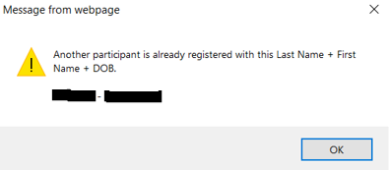

FIX EXCEPTION ERROR WHEN UTILIZING PARTICIPANT FILTERS

Purpose
TEAMS was throwing an exception error when users tried to filter certain reports by participant profile variables. The exception error has been fixed.

Reports > Participant > Period of Participation > Participant > Profile Variables
