TEAMS 5.4.1|Release Date 12.15.2020

ADDITION OF NEW PIRL ELEMENTS

Purpose
TWC AEL programs are required to report jointly with other WIOA Title programs. There is certain participant demographic information that must be collected and reported as part of this joint report to OCTAE/DOL each year. Grantees are required to add these new elements to their intake and enrollment forms/procedures to ensure that we follow federal reporting guidelines. These elements will consist of two changes:
NEW ELEMENTS—Not previously collected
MODIFIED ELEMEMTS—Previously collected but adjustments to dropdown to include additional options not formerly offered, such as ‘Chose Not To Disclose’.

New Profile Elements
The participant record and profile in TEAMS will have some new elements that must be collected. You will find this on the participant profile made when creating a new profile in TEAMS.
Home> Participant Search> Participant Record> Add New Profile

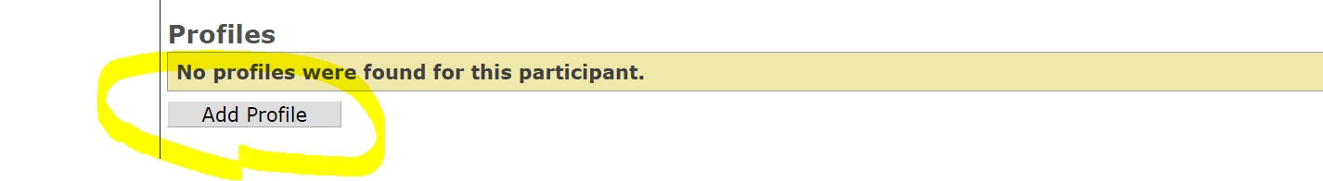

New Elements
We added the following fields below to the ‘One-Stop Program Participation’ section in the following order, all elements are required and need a response (exception YouthBuild number). If left blank, user will receive a “(Element Name) is required”:
  - WIOA Adult is a required (*) field.
  - WIOA Dislocated Worker is a required (*) field.
  - WIOA Youth is a required (*) field.
  - Adult Education is automatically set to ‘Yes’
  - Job Corps. Change the label of the One-Stop Program Participation > Participant received services under Title 1, Chapter 4, Subtitle C of WIOA (Job Corps) field to Job Corps and make it a required (*) field.
  - Vocational Rehabilitation is a required (*) field.
  - Wagner-Peyser Employment Service is a required (*) field.
  - YouthBuild Grant Number. Allow the user to enter 14 alpha-numeric character (no dashes, no special characters) grant number into a text box.
    - The grant number must be in the following format where A=alphabetical character and #=numerical character: AA#########A##. If the YouthBuild grant number is not in this format, TEAMS will display the message, “YouthBuild is invalid. It must be in the following format: AA#########A##.”
      - Per the Joint PIRL, “The grant number should be entered in the following format without dashes: Two alphabetic characters representing the grant program code-Five numeric characters-Two numeric characters representing the fiscal year when the grant was awarded-Two numeric characters identifying the type of grant awarded-One alphabetic character identifying the relevant agency at ETA-Two numeric characters identifying the state that received the grant was served under (AA-12345-12-55-A-26).”
    - The user must be allowed to save 99999999999999 in the event the user does not know the YouthBuild Number. This is the only exception to the rule above.
    - If the student does not have a YouthBuild grant number, allow the text field to be left blank.

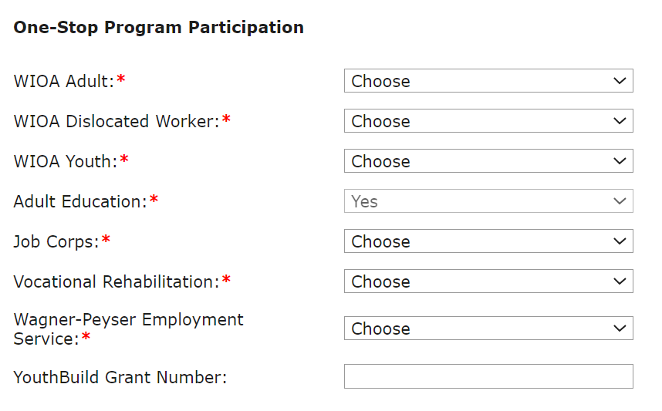

Modified Elements
These are elements that have been previously collected, but have received modification to align to new federal guidance on PIRL requirements.

Migrant Seasonal Farmworker
You will notice on old profiles, we had to convert some older data, such as:
- If the student’s Migrant Seasonal Farmworker Status = A dependent of a seasonal, or migrant seasonal farmworker on any profile between PY 2016-2017 through PY 2020-2021 convert:
  - To 4-Dependent Adult if Age as of the start date of the PY (07/01/YYYY) is > 24.
  - To 5-Dependent Youth if Age as of the start date of the PY (07/01/YYYY) is <= 24.
- If the student’s Migrant Seasonal Farmworker Status = Seasonal Farmworker OR Migrant and Seasonal Farmworker on any profile between PY 2016-2017 through PY 2020-2021 convert:
  - To MSFW Youth if Age as of the start date of the PY (07/01/YYYY) is <=24.
- If the user tries to save Migrant Seasonal Farmworker Status = Seasonal Farmworker Adult, Migrant Worker Adult, or Dependent Adult and the Age as of the start date of the PY (07/01/YYYY) <=24, display the message, “The Age as of the start date of PY is less than or equal to 24. You must select Migrant Seasonal Farmworker Status = MSFW Youth OR Dependent Youth.”
- If the user tries to save Migrant Seasonal Farmworker Status = MSFW Youth or Dependent Youth and the Age as of the start date of the PY (07/01/YYYY) > 24, display the message, “The Age as of the start date of PY is greater than 24. You must select Migrant Seasonal Farmworker Status = Seasonal Farmworker Adult, Migrant Worker Adult, OR Dependent Adult.”

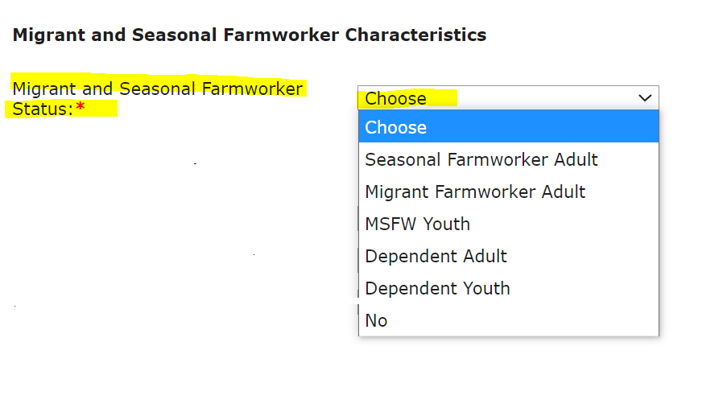

Additional Reportable Characteristics
We relabeled some elements to ensure that they aligned to most recent PIRL guidance.
- Change the label of the Additional Reportable Characteristics > Homeless Status dropdown to Homeless /Runaway Youth Status.
  - Change the “Homeless Status is required” message to “Homeless/Runaway Youth Status is required.”
- Hide the Additional Reportable Characteristics > Dislocated Worker dropdown.

Updated Dropdowns
We also updated options in dropdowns on certain elements, such as: Single Parent, Cultural Barriers, and Gender. There will be additional option other than Yes/No, such as “Participant Did Not Self Identify”. For a Full List, see document titled: “Instructions for AEL Enrollment Forms”

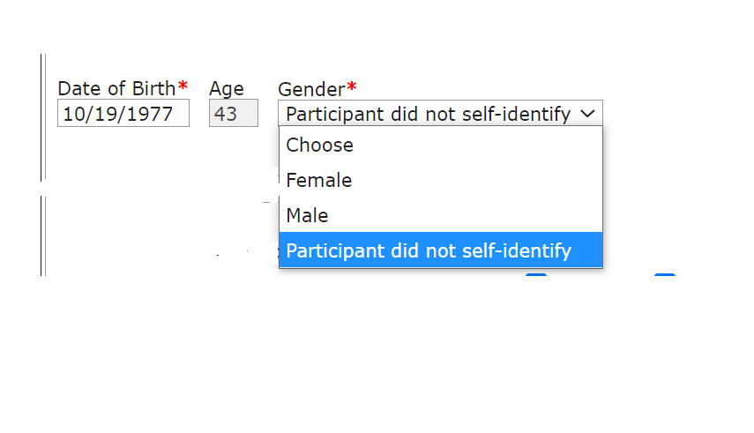

Other Profile Changes
Removal of Non-PIRL profile characteristics such as Participant Goals and Achievements. These will be added to a future release under the new ITEC plan page.

REMOVE EDUCTIONAL OUTCOME DUPLICATION

Purpose
Currently, TEAMS displays a row for each Grant Recipient (GR) that gets credit for an educational outcome. The rows are identical and do not identify the credited Grant Recipient. This causes confusion because it looks as if there are erroneous duplicated rows. This release will add a Grant Recipient column to all the tables on the Educational Outcomes page. It must be populated with each Grant Recipient that gets credit for the educational outcome separated by a comma. So, there will be one row per educational outcomes (instead of duplicates), and all the GRs that get credit for it will be visible.
After TEAMS Release 5.4.1, TEAMS will show all Grant Recipients that are receiving a gain when a student receives an outcome. If the student was served by multiple Grant Recipients in a period of participation, the outcomes related to MSGs and Credential are shared by each Grant Recipient.

