TEAMS 6.6|Release Date 12/2/2024

# NEW MSG OPTION – TYPE 1d – PASSING HSE SUB-TEST

## Purpose

MSG 1d Passage of State approved HSE Sub-Test.

Participants can receive type 1d gains in two ways:

* When GED Match loading HSE test(s) received from TEA into TEAMS and the score is >= 145 and administered date >= 7/1/2024.
* Can be entered manually from MSG page.

On release day, data script created 5,701 Type 1d gain for the existing HSE tests on/after 7/1/2024.

## Business Rules

1. Participant should meet the following existing MSG rule to enter type 1d gain:
   1. Participant must have profile in current school year to add measurable skill gain.
   2. Achieved Date must be in the current school year.
   3. Documentation must be kept in participant record.
2. Changes to the Educational Outcome MSG Gains details page:
   1. New value to the ‘Passing HSE Sub-test’ to the EFL Gain Type dropdown. This dropdown is enabled when the selected Measurable Skill Gain Type is ‘Educational Functional Level (EFL) Gain’.
   2. Save button is enabled when the selected EFL Gain Type is ‘Passing HSE Sub-test’.
   3. Add Content Area dropdown, populate with the content areas of test type 31 – GED Computer Test, that are:
      1. Mathematical Reasoning
      2. Reasoning Through Language Arts
      3. Science
      4. Social Studies

**Note:** Type 31 – GED Computer Test is the only active HSE test.

* 1. Add Score text box.
  2. Enabled controls/fields to enter type 1d gain:
     1. Reporting Year - required
     2. Achieved Date - required
     3. Measurable Skill Gain Type - required
     4. EFL Gain Type - required
     5. Content Area - required
     6. Score – required. Score must be > 144. Validation message “The score must be > 144.” displayed when the score entered is below 145.
     7. Educational Provider – not required, free flow text.
     8. Details - required
  3. Type 1d gain is considered duplicate when the achieved date, content area, score is same. TEAMS prevents entry of duplicates when user tries to enter type 1d gain with achieved date, content area, score same as an existing type 1d gain of the participant by displaying this validation message “Participant has a Passing HSE Sub-test gain with the same achieved date, content area, and score.”

For e.g. A participant has a type 1d gain with achieved date 10/1/2024, content area Science with score 155. When a user tries to enter another type 1d gain with achieved date 10/1/2024, content area Science and score 155, TEAMS prevents the entry.

* 1. For a participant, multiple type 1d gains can be entered with the same achieved date but either content areas or score must be different.

1. Entering type 1d gains in the MSG page should not create any corresponding credentials as credentials can be achieved only on passing GED Test battery and should be verified by TEA.
2. All the additional grant recipients who created the profile in the year in which type 1d gain achieved date falls in must get credit on it.
3. Any number of type 1d gains can be entered as long as the content area, score, achieved date are different.

## Prototype Screen – Home > Participant > Educational Outcomes > MSG > Add Gain Manually

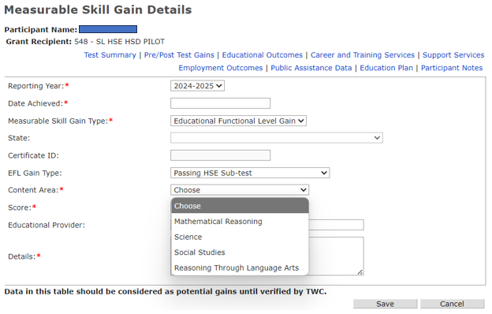

## Prototype Screen – Home > Participant > Educational Outcomes > MSG Page

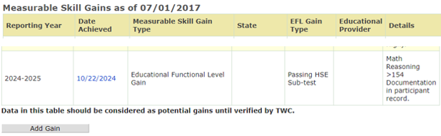

**TxCHSE GED Match Job:**

When TxCHSE GED Match job is loading HSE test(s), type 1d gain(s) should be generated for each passing content area with score >= 145 and the test administer date >= 7/1/2024.

* + - 1. Type 1d gain should be generated for each content area of the HSE test.

2. After GED match is laid out the HSE test for the participant, and the participant has profile in the year in which test administer date falls then it’ll:

* 1. Check if participant has the gain manually entered with the same achieved date, content area, and score, if exists, set the type 1d gains will display the gain verified by data match in “Verified by Data Match” check box.
  2. 1d gain will also display in the Educational Outcome MSG grid page.
  3. When manually entered type 1d gain is not found then generate it by populating the following details:
     1. Measurable Skill Gain Type – Educational Functioning Level
     2. EFL Gain Type - Passing HSE Sub-test
     3. Achieved Date – HSE test administer date
     4. Content Area – Content Area of the HSE test
     5. Score – Score from the HSE test
     6. Details - Gain verified by TEAMS TXCHSE match batch job
     7. Assessment ID – Populate the assessment ID of HSE test. Note that this doesn’t display in the MSG page but behind the scenes in the database, type 1d gain is linked to the corresponding HSE test that caused the gain.
  4. Batch flag of type 1d gain indicates the gain is generated or verified (manually entered type 1d gains) by the GED Match job and can’t be editable/deleted by the user. Save and Delete buttons aren’t shown in the MSG Details page.
  5. All the additional grant recipients who created profile in the year in which type 1d gain achieved date falls must get credit on it.

3. After laying out the HSE test in TEAMS and participant doesn’t have a profile in which test administer date falls in then do not generate the type 1d gain. The participant will receive the type 1d gain on the passing HSE test when profile is created.

For e.g. Participant’s last profile is for the 2023 – 2024 PY. He received passing HSE tests with date 10/4/2024 from TEA, GED Match loads HSE tests for the participant but wouldn’t create type 1d gain due to lack of profile for the 2024 – 2025 PY. Creating profile for the 2024 – 2025 PY generates the type 1d gains with same info as #2c.

## Prototype Screen – Home > Participant > Educational Outcomes > MSG > MSG Add Gain > Measurable Skill Gain Detail > GED Match Job Loaded Verified by Data Match & Details

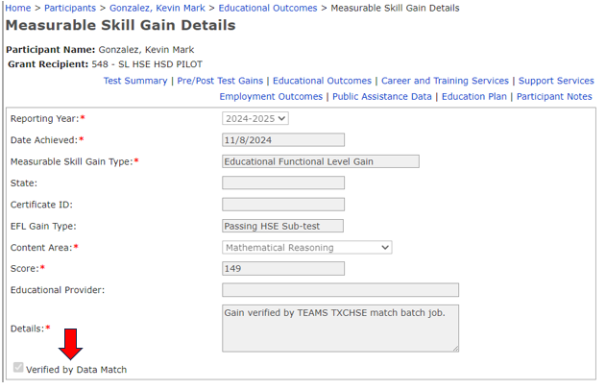

## Prototype Screen – Home > Participant > Educational Outcomes > GED Match Job Loaded

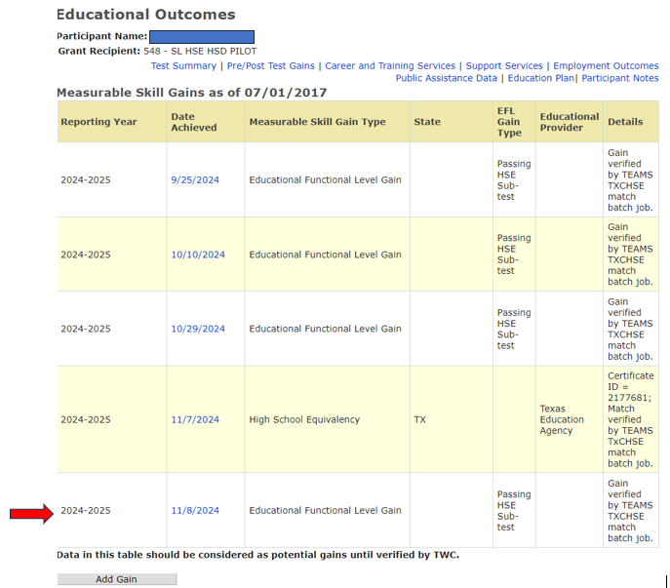

## Prototype Screen – Home > Participant > Test Summary > Other Tests

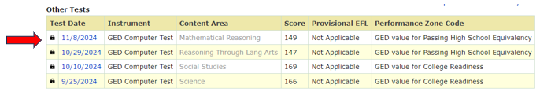

**Measurable Skills Gain (MSG) Report:**

1. The ‘Latest HSE Sub-Test’ column has been added to the MSG Summary report. Display Achieved Date and Content Area of the latest ‘Passing HSE Sub-test’ gain separated by comma.

Note that when the latest type 1d gain has multiple content area then all of them displayed separated by commas.

1. The following columns to the MSG Extract report:
   1. Latest HSE Sub-Test Achieved – Display Achieved Date of the latest ‘Passing HSE Sub-test’ gain.
   2. Latest HSE Sub-test Content Area – Display Content Area of the latest ‘Passing HSE Sub-test’ gain. Note that when the latest type 1d gain has multiple content area then all of them displayed separated by commas.
2. The MSG report description includes Latest HSE Sub-Test Achieved and Latest HSE Sub-Test Content Area:

**Latest HSE Sub-Test Achieved**

**Description:** The Participant’s latest Achievement Date for MSG 1d Passage of State approved HSE Sub-Test. Documented passage of a sub-test on a State-recognized HSE exam. Passage must be within the same program year.

* Note 1: MSG 1d Gain must be within the RY.
* Note 2: An MSG 1d gain is not GR-specific.

**Latest HSE Sub-test Content Area**

**Description**: The Participant’s latest Content Area consist of passing a section of the HSE Exam.

* Note 1: MSG 1d Gain must be within the RY.
* Note 2: An MSG 1d gain is not GR-specific.

## Prototype Screen – Home > Report > Participant > Management Summary Report > Summary Report

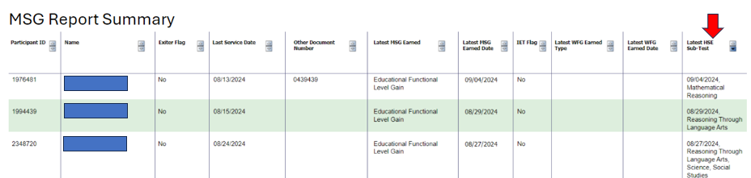

## Prototype Screen – Home > Report > Participant > Management Summary Report > Extract Report

