TEAMS 6.4|Release Date 1/5/2024

MODIFY PROFILE PIRL TO MATCH THE JOINT PIRL

Purpose

Modify TEAMS Profile Participant Individual Record Layout (PIRL) to match the Joint PIRL.

Business Rules

Modify Profile PIRL to match the Joint PIRL.

Participant Record Modifications:
- Add “Participant did not self-identify” to Ethnicity dropdown list
- Add “Participant did not self-identify” to Race add check box
  - If box is checked, do not allow user to select any other values under Race.
  - If box is selected after a participant has selected “Participant did not self-identify” System will generate the following error message:
“Can not apply other Race options if “Participant did not self-identify” is selected.”
- Add “Status not known” to Veteran Status dropdown list.

Prototype Screen – Home > Participant > Personal Information > Ethnicity

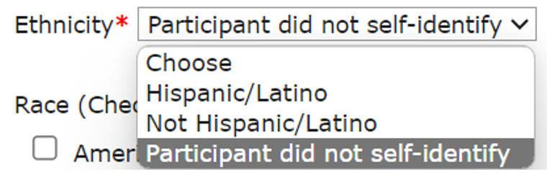

Prototype Screen – Home > Participant > Personal Information > Race

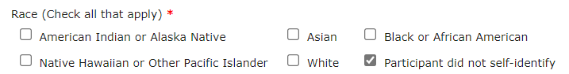

Prototype Screen – Home > Participant > Personal Information > Race > If “Participant did not self -identify and check other option will get an error message.

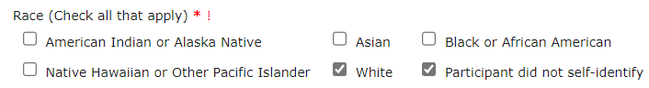

Prototype Screen – Home > Participant > Personal Information > Race > Error Message

Prototype Screen – Home > Participant > Profile > Veteran Characteristics > Veteran Status

