TEAMS 6.3|Release Date 09.19.2023

PARTICIPANT PROFILE: EQUAL OPPORTUNITY INFORMATION AND VETERAN CHARACTERISTICS

Purpose
When creating a new participant profile option for Equal Opportunity Information – Disabled or Veteran Characteristics – Veteran Status, Eligible Veteran Status, Disabled Veteran, and Veteran Spouse if you answered “Yes” to either option it would revert to “No”. This has been fixed.

Prototype Screen – Home > Participant > Profiles > Add New Profile

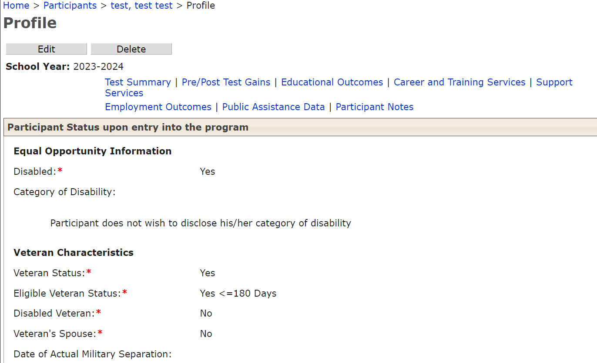

MODIFIED THE GEDMATCH PROCESS TO NOT INSERT

A DUPLICATE SSN OR GEDID

Purpose
Modify the GEDMatch process by adding an additional check to prevent the insertion of a duplicate SSN or GED ID. When the return file is received from TEA, the data from this file gets inserted into three staging tables. GEDMatch uses these staging tables to load GED data into TEAMS tables after the participant comparisons between TEAMS and TEA data.

Current GEDMatch process:

- When SSN exists in both the systems then match by SSN, if they are matched then loads HSE info into TEAMS.

- When participant doesn’t have SSN in either one of the systems then match by Last Name, First Name and DOB.
- When all these three fields matched and only one participant existed then GEDMatch load HSE info.
- While loading HSE info, GEDMatch looks to see if the participant doesn’t have SSN in TEAMS but has in TEA or return file then it loads the SSN into TEAMS and checks a flag to indicate this. This is where duplicates are happening.
- When multiple participants found by names and DOB, GED Match doesn’t load HSE info and puts the participants into non-match table or page.
New modified GEDMatch process:

1. GEDMatch process will check for a duplicate SSN in the TEAMS application before assigning SSN to participant included in seed file. A duplicate SSN is detected if the SSN is already assigned to any participant in TEAMS.

GEDMatch process will check for duplicate SSN in [T_PARTICIPANT] table.

- If there is NO SSN duplicate detected: Assign HSE information to participant included in the seed file and assign SSN to same participant match.

- If there IS an SSN duplicate detected: Do Not assign SSN to participant profile included in the seed file exchange BUT Do assign HSE information to participant profile included in the seed file exchange.

Notes: If SSN exist in TEAMS on a record not including in the seed file criteria, HSE data will instead be included on most current record in the seed file that matches GED match criteria. Seed file criteria consist of a participant that has/have a profile in the current year or in the previous year.

