TEAMS 6.1|Release Date 01.20.2023

NEW PERIOD OF PARTICIPATION (POP) EXITERS MANAGEMENT REPORT

Purpose
The newly created POP Exiters Management Report has information to assist users with managing performance by understanding what information is available in TEAMS by quarters after exit. It lists Exiters and shows any MSG, Credential, Employment or Post-Secondary Enrollment that has been reported in TEAMS within each quarter after exit for timeframe of the report pull. This report is to help manage performance but is not a performance report and does not use specific calculations to determine who is in the denominator or numerator for certain exit based outcome measures.

Prototype Screen – Home > Reports > Participants > POP Exiters Management Report
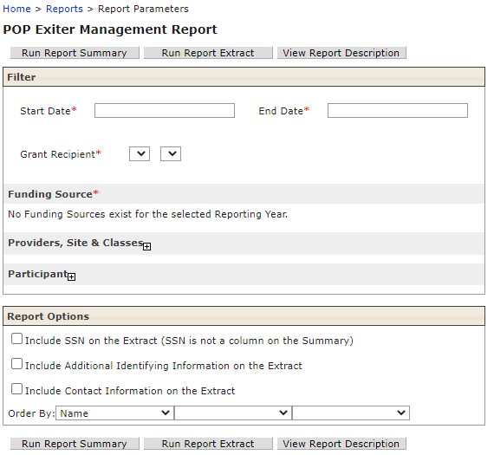

The report universe is an unduplicated list of periods of participation by POP ID whose Last Service Date plus 90 days within the report date range. See POP Exiter Management Report description attached.

The report date range cannot be greater than one calendar quarter. If the user attempts to add a Start Date and an End Date in a different calendar quarter, display the message, “The report Start Date and End Date must be in the same calendar quarter”. For example: Q1 July 1 – Sept 30, Q2 Oct 1 – Dec 31, Q3 Jan 1 – Mar 30, and Q4 Apr 1 – Jun 30.

Prototype Screen – Home > Reports > Participants > POP Exiters Management Report > Report Summary
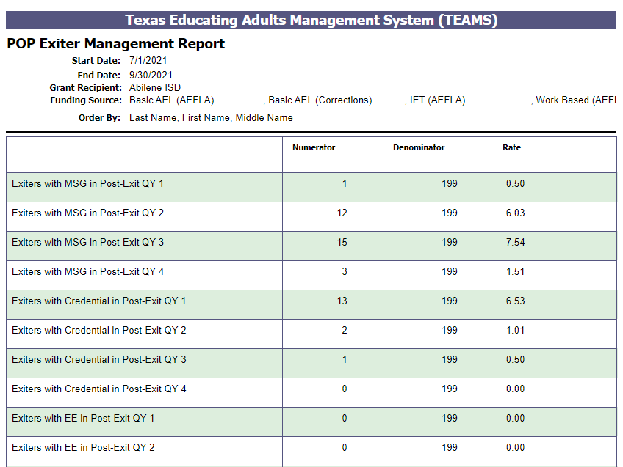

Prototype Screen – Home > Reports > Participants > POP Exiters Management Report > Report Extract
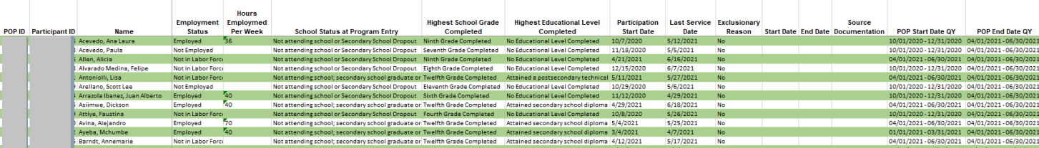
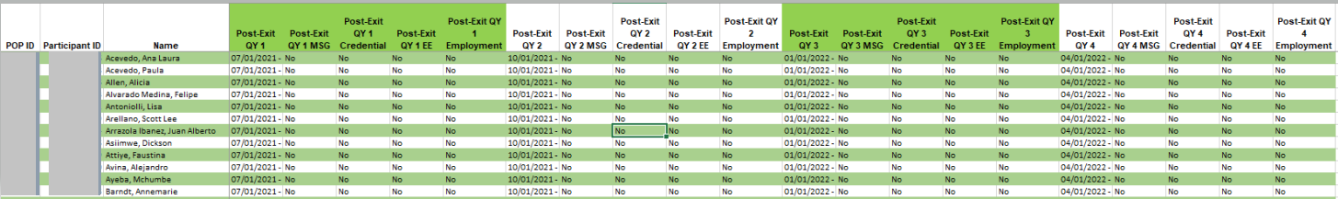

MODIFY MEASUREABLE SKILLS GAIN (MSG) MANAGEMENT REPORT &

PARTICIPANT OF PARTICIPATION (POP) REPORT

Purpose
The MSG Management Report and POP Report have been modified as follows:

- MSG/POP Report ability to select multiple Providers in the report filter by holding the Ctrl button
- POP Report changed Participation ID to POP ID and switch the location of POP ID and Participant ID.
- MSG Management Report to include all the participant’s MSGs for the time period that Report is submitted for, not just the most recent.

MSG/POP Report – Select Multiple Providers

Prototype Screen – Home > Reports > Participant > MSG Management Report > Providers, Sites & Classes > Provider > Load Sites
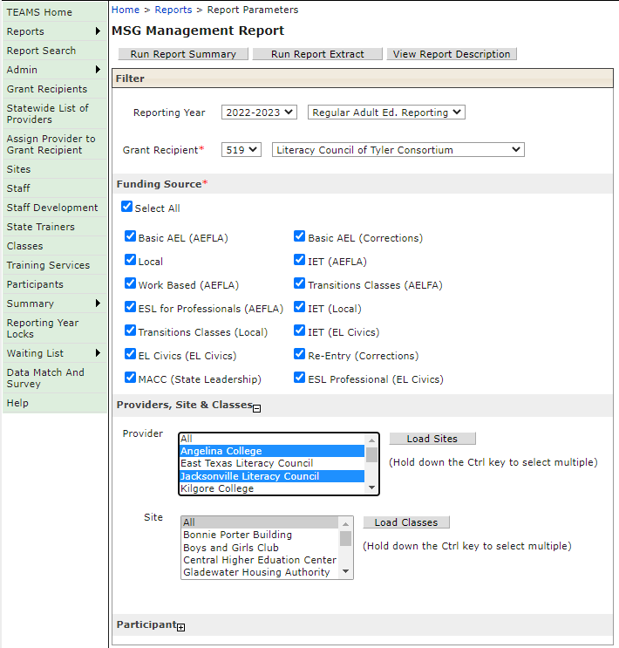
POP Report – Select Multiple Providers Report Summary

Prototype Screen – Home > Reports > Participants > POP Report > Providers, Sites & Classes > Provider > Load Sites > Run Report Summary

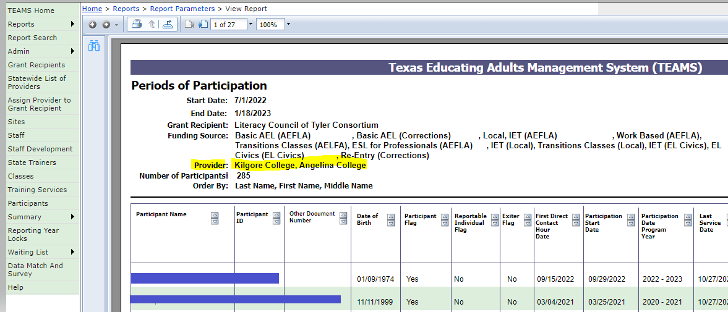

POP Report changed Participation ID to POP ID and switched location on the report.

Prototype Screen – Home > Reports > Participant > POP Report > Run Report Extract

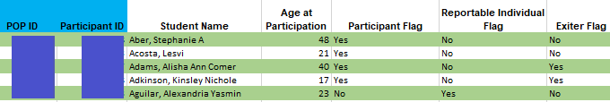
MSG Management Report to include all the participants MSGs for the time period that Report is submitted for, not just the most recent.

Prototype Screen – Home > Reports > Participant > MSG Management Report > Run Summary Report
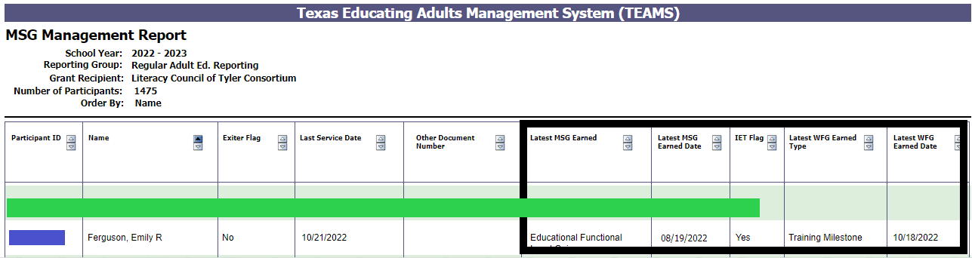

Prototype Screen – Home > Reports > Participant > MSG Management Report > Run Extract Report

DATA FIXES: UPDATE AND MODIFY PARTICIPANT - DUPLICATE HOURS, PROFILES, AND TEST LEVEL

Purpose

TEAMS data request fix from Grant Recipients are as follows:

- Victoria Jr College (PID 1921243/1510162/299320/2235393/472466) – Correct duplicate contact hours for participants for Class: aaPM Math III – Hybrid, Class Number: AEL52HSE627.
- Austin Community College (PID 1624211) – Correct participant incorrect profile from 2018-2022 -Secondary School Graduate or Equivalent – should be “No Educational Level Completed”.
- Howard College Concho Valley (PID 2169587) – Correct Test Level for participant.

