TEAMS 5.8.2|Release Date 03.11.2022

ALLOW HSE SUPPORT SERVICE FOR INDIVIDUALS WHO HAVE A HS DIPLOMA OR HIGHER LEVEL ‘OUTSIDE THE US’

Purpose
Allow users to add Support Service Type: HSE Voucher to participant who have high school diploma or higher level of education in a country ‘Outside the US’. User’s will also be allowed to add Support Service Type: HSE Voucher to participants whose Profile is ‘In the US’ and has select ‘No Educational Level Completed’ as well.

Business Rules
Participant ‘Outside the US’
- In order to allow user to add Support Service Type: HSE Voucher for participants ‘Outside the US’; the participant must have the following requirements met in their participant profile. If the participant profile has the following selected in Highest Education Level Completed:
  - Field 1:
- Attained secondary school diploma
- Attained a secondary school equivalency
- The participant with a disability receives a certificate of attendance/completion as a result of successfully completing an Individualized Education Program (IEP)
- Completed one or more years of postsecondary education
- Attained a postsecondary technical or vocational certificate (non-degree)
- Attained an Associate’s degree
- Attained a Bachelor’s degree
- Attained a degree beyond a Bachelor’s degree
No Educational Level Completed
Note: Any of the following options are valid and must be select in Field 1.
  - Field 2:
    - Outside the US

Prototype Screen – Home > Participant > Profile > School Year > Employment and Education Information > Highest Educational Level Complete

Participant ‘In the US’
- Allow users to add Support Service Type: HSE Voucher for participants ‘In the US’ if they select ‘No Education Level’. If participant profile has the following selected in Higher Education Level Completed:
  - Field 1:
    - No Educational Level Completed
  - Field 2:
    - In the US

Prototype Screen – Home > Participant > Profile > School Year > Employment and Education Information > Highest Educational Level Completed

Error Message
- If a participant does not meet the conditions above; prevent user from entering Support Service Type: HSE Voucher and display error message:
“You cannot save an HSE voucher code because the participant’s Highest Education Level Completed indicates they are not eligible for HSE voucher.”

HSE Voucher False Requirement Flag
- If a user changes/edits a participant profile “Highest Educational Level Completed:” fields after successfully adding Support Service Type: HSE Voucher to different values apart from the original “Highest Educational Level Completed” values, generates the following message:
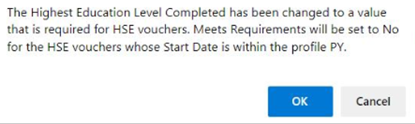
If user clicks ‘OK’
Participant Edits/Changes are saved and processed and HSE Voucher is generated to null.
Else if user clicks ‘Cancel’
Participant Edits/Changes are not processed, and the User remains on the same page.

MODIFY MSG MANAGEMENT REPORT

Purpose
The Measurable Skills Gain (MSG) Management Report rules were modified to ensure that the report creates a snapshot of the program year participants and MSG’s earned regardless of when the report is pulled by including an unduplicated list of Participants (by Participant ID) whose Participant Flag is ‘Yes’ and Last Service Date has greater than zero contact hours (except training hours that continue in isolation > 60 within the Program Year/Reporting Year (PY/RY)). The report will also now pull all Type 1b (Exit and Entry into Post-Secondary Education) from the MSG table, not the Educational Enrollment table, because until conditions and criteria are met (exit flag = yes) educational enrollment may not apply as an MSG in the PY.

Navigation

MSG Management Summary Report
Reports > Participant > MSG Management Report > Run Report Summary

MSG Management Extract Report
Reports > Participant > MSG Management Report > Run Extract Report

MSG Management Report Description
Reports > Participant > MSG Management Report > View Report Description

Business Rules

- Update MSG Management Report column: “Latest MSG Earned”, change display of PSE from Educational Enrollment table to Measurable Skill Gain table.
- Update MSG Management Report column: “Latest MSG Earned Date”, change display of PSE from Educational Enrollment table to Measurable Skill Gain table.
- Display participant s that has an open POP in the selected PY whose MSG was earned in the previous PY.
- Gather unduplicated list of Participants (by Participant ID) for all PY’s that are between participants start date (of the POP) and the Last Service Date.

ALLOW WORKPLACE LITERACY PARTICIPANTS TO RECEIVE A WORKFORCE MSG

Purpose
Allow Workplace Literacy Participants to receive Workforce MSG who are funded by these three funding sources:
- 19 – Worked Based (AEFLA)
- 34 – Work Based (Local)
- 58 – Work Based (El Civic)

Participants must also have contact hours >0 and the date achieved of Workforce MSG must be >= the first contact hour date in any one of the three funded sources above. Note: Contact hours include only Direct and Proxy hours. Training hours do not count towards determining credit.

Workforce MSG includes 3 MSG Types:
- 3 – Transcript/Report Card
- 4 – Training Milestone
- 5 – Skills Progression

Business Rules

- Workplace Literacy Participant Requirements:
  - Participant must be funded by the funding Fund Sources:
    - 19-Work Based (AEFLA)
    - 34-Work Based (Local)
    - 58-Work Based (El Civic)
  - Participant must have Direct or Proxy contact hours >0, Training hours are excluded.
  - WF MSG must include the following type:
    - 3–Transcript/Report Card
    - 4-Training Milestone
    - 5-Skills Progression
  - WF MSG date achieved must be >= the first Direct or Proxy contact hour date.
- If Participant has multiple Grant Recipients:
  - Grant Recipient must have Direct or Proxy contact hours >0 in the same PY as the Req (1.3) WF MSG date achieved.
  - Grant Recipients do not need the Req (1.1) funding sources if the original Grant Recipient already has the Req (1.1) funding source.
- Contact hours update/changes:
  - On entering, deleting or updated hours, Req (1.3) MSG’s should be re-evaluated to check if the type 4 MSG is still valid per Grant Recipient following the above requirement. If multiple Grant Recipients the original Grant Recipients deletes the Req (1.3) MSGs, then it must be deleted for the additional Grant Recipients as well.
  - On deletion, any change made to Req (1.3) MSG’s will be tracked in MSG history table.
  - When the user deletes the Req (1.3) MSG, TEAMS will display the message, “The Participant has an existing Training Milestone MSG. Deleting the Contact Hours will remove the Training milestone MSG. Click on the continue button to delete the Training Milestone MSG. Click on the cancel button to NOT delete the Training Milestone MSG.”
- Funding Source update/changes:
  - On updating, or deleting funding source, Req (1.3) TEAMS will re-evaluate to check if the Req (1.3) MSG’s is still valid per Grant Recipient following the above requirements.
  - Multiple Grant Recipients, if the original Grant Recipient deletes the Req (1.3) MSG’s due to funding source being updated/deleted, then it must be deleted for the additional Grant Recipient as well.
  - On deletion or if funding sources are changed to any other type besides the given 3, Req (1.3) MSG’s will be tracked in MSG history table.
  - When the user deleted the changes or deletes the funding source type besides the given 3, display the message, “The Participant has an existing Training Milestone MSG. Deleting or change the Funding Source will remove the Training Milestone MSG. Click on the continued button to delete the Training Milestone MSG. Click on the Cancel button to NOT delete the Training Milestone MSG.”
  - Workforce MSG success, if participant meets all requirements in Workplace Literacy Participant Req., allow participant to gain type Req (1.3) MSG’s.
  - Workforce MSG error, if participant does not meet requirements in Workplace Literacy Participant Req., Do NOT allow participant to gain Req (1.3) MSG’s. Display error message: “Participant must have profile and be registered to a class assigned to a Training Service in the program year in which you are attempting to add a WF MSG. OR Participant must have contact hours >0 funded by any of the following: (Worked Based (AEFLA), Work Based (Local), or Work Based (El Civics)) AND Date Achieved must be >= at least one of the dates of these contact hours.”

ADD FEIN TEXT BOX WHEN WORKPLACE LITERACY IS ACTIVATED IN COURSEWORK

Purpose
Add the Federal Employer Identification Number (FEIN) text box when Workplace Literacy is activated as Coursework.

Prototype Screen – Home > Class > select Class > edit/add Class Information

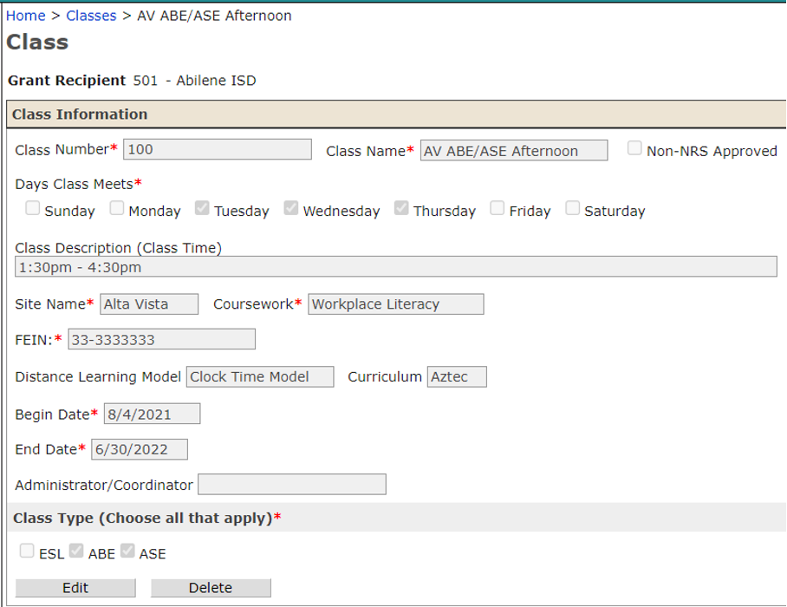

Business Rules

- If User does not select Workplace Literacy under Coursework; FEIN remains blocked, and user is unable to enter FEIN.
- If User selects Workplace Literacy under Coursework; allow user to enter FEIN.
- FEIN Textbox:
  - Allow user to enter only 9-digit numbers in textbox
  - Textbox format must be:
    - XX-XXXXXXX
    - XXXXXXXXX
  - If User enter XXXXXXXXX format, textbox will default entry to format XX-XXXXXXX format.
  - If User leaves FEIN textbox empty, error message will follow: “FEIN is required. FEIN must contain 9 numerical characters and must adhere to the following format XX-XXXXXXX OR XXXXXXXXX.” Prompt User to enter the FEIN again. (User is not allowed to leave FEIN textbox empty).
  - If User enters less than 9 digits or characters that are not numerical; an error is created, and User is prompted to try again. Error message: “Please enter a valid FEIN. FEIN was entered incorrectly. FEIN must contain 9 numerical characters and must adhere to the following format XX-XXXXXXX OR XXXXXXXXX.”

MODIFY STAFF TO REDUCE THE PD HOURS REQUIREMENTS BY 6.0 HOURS

Purpose
Modify Literacy Instructor Staff to waive the Professional Development (PD) hour requirements by 6.0 hours of Literacy PD if College Level Credit Coursework in Literacy Instruction Area >= 18 hours.

As defined in Chapter 805. Adult Education and Literacy, Subchapter B. Staff Qualifications §805.21 Staff Qualifications and Training line 38-41 (iv) waive six clock hours of content area in staff professional development for individuals who have 18 or more college semester undergraduate or graduate credit hours in relevant area of literacy instruction.

Business Rules

- If Literacy Instructor Staff have >= 18 hours in College Level Credit Hour Coursework in Literacy Instructional Area, in the current PY, reduce the PD hour requirement by 6.0 hours.
- This rule remains in effect for every PY that the staff has an employment record and regardless of his/her begin date.
- TEA Business rule revocation (Inherited from TEA): Current rule check whether the staff has certain number of development hours based on their job type enforced when the staff has previous year employment. Removed: When the job type is ‘Literacy Instructor’ college level credit hours form previous year’s qualifications are added to development hours.

Prototype Screen – Home > Staff > search Staff > Qualifications > School Year

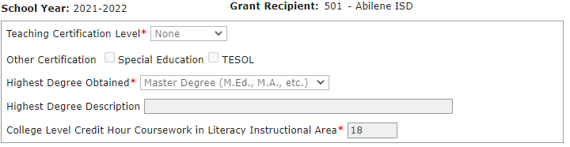

REMOVE PRE-SERVICE OPTIONS FOR PD REQUIREMENT

Purpose
Remove Pre-Service option from Staff Professional Development (PD) requirements. Pre-Service is not an option that is used in the current TEAMS iteration and removing it will help prevent usage.
Removed the Pre-Service option in the drop-down under the staff development type.

Prototype Screen – Home > Staff Development > Staff Development Activity Details > Record Hours > edit/add Staff

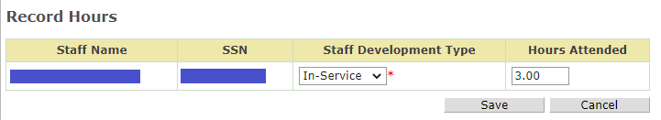

FIX MISSPELLED MONTH (FEBRUARY) IN TEAMS

Purpose

Fixed misspelled month (February) in Class contact hour periods, Participant Roster Sign-In Sheet.

Prototype Screen – Home > Classes > select Class > Contact Hour Periods

