Move Ahead with Adult Ed
Texas Adult Education & Literacy
Move Ahead with Adult Ed
Adult education programs help you prepare for your career. Training can help you prepare for college. Training can also help you prepare for work and increase income.

Learn Skills to Get Back to Work
The Texas Workforce Commission has 98 adult education providers statewide. Programs offer skills training to get you back to work. English language. Literacy and numeracy. High school equivalency. In-demand industries.

Virtual and In-person Learning
In 2020, most providers began offering classes online. Many providers continued to offer classes in person. Some offer both online and in person. Instructors follow social distancing rules and comply with local mandates.

Student Testimonials
“Pursuing adult education has set up pathways for multiple careers for me and has made a huge impact on everything I’ve done. This was the fastest way to get me where I needed to be.”
– Bentley Gamblin, Amarillo College
“This is the opportunity I was looking for. I’m so proud that I did this and got a job that I want.”
– Jocelyn Repato, SISD Community Education, El Paso

Adult Education Can Increase Earnings

$9,620
How much more a person
with a high school diploma or equivalent earns, on average, than a non-graduate.

63 %
The percentage of all U.S. jobs that
require at least a high school diploma.
43,000,000
The number of working-age adults in the U.S. who lack the skills needed for many of the nation’s fastest growing and highest paying jobs.²
73%
The percentage of adults who
attained a high school equivalency (HSE) or another indicator of high school completion after participating in federally funded HSE programs and taking all the HSE subtests.1

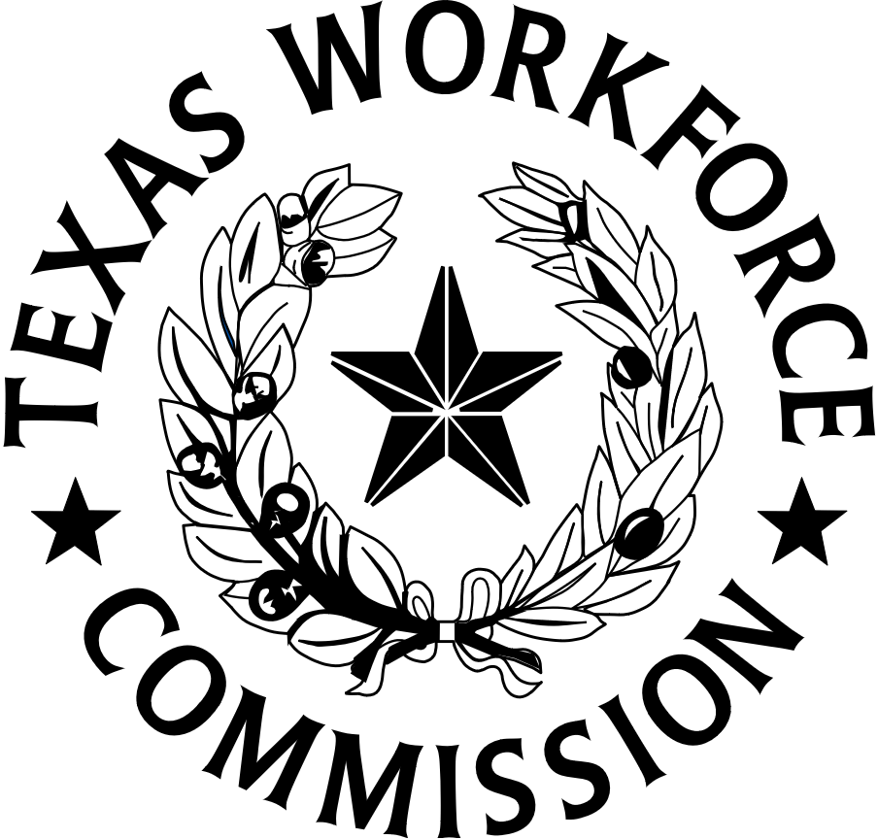
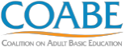
Insert provider
logo
Equal Opportunity Employer/Program. Auxiliary aids and services are available upon request to individuals with disabilities. TWC accepts calls made through any relay service provider. TexasWorkforce.org
This project is wholly funded with Federal workforce development funds.

1 “Congressional Justification (2019). Career, Technical, and Adult Education Fiscal Year 2020
Budget Request.” U.S. Department of Education • 2 Mamedova, Saida and Emily Pawlowski. “Adult Literacy in the United States.” Data Point, National Center for Education Statistics, July 2019, https://nces.ed.gov/datapoints/2019179.asp.
Find a Program Near You:
https://tcall.tamu.edu/search.aspx

