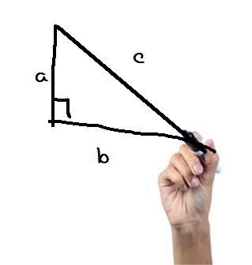
Need Assistance with Math??
Get One-on-One Math Help
with the
Math Assistance Call Center (MACC)

Contact Information
- FREE
- Use a computer, smart-phone or landline
- View solutions with interactive white board
- Spanish-speaking tutors available
- Open 7am – 10 pm Central Time
Toll Free: (888) 260-4257
Web: www.studentnest.com
Click on “Live Chat”
Email: tutoring@studentnest.com
Questions about the program?
Contact: 1-888-260.4257
Before you call, please have the following information ready to give the tutor:
- Your program name
- Your program location
- Your TEAMS record number
Provided by your instructor

