Surface Go Quiz (Basic)

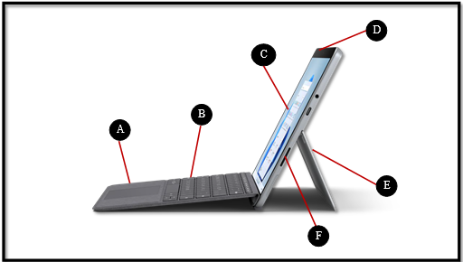
Source: https://www.microsoft.com/en-us/d/surface-go-3/904h27d0cbwn?rtc=1&activetab=pivot:overviewtab
- _______________________________
- _______________________________
- _______________________________
- _______________________________
- _______________________________
- _______________________________

Word bank:
Keyboard kickstand charging port touchpad screen power button

Surface Go Quiz (Advanced)
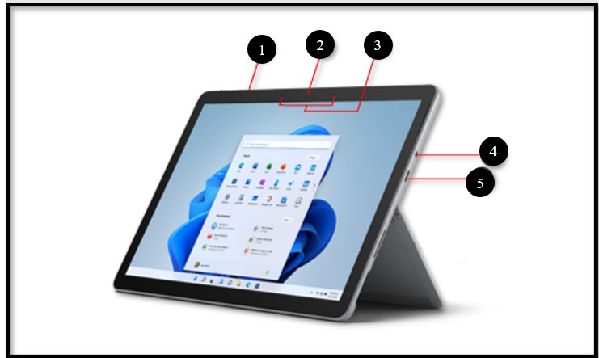
Source: https://support.microsoft.com/en-us/surface/surface-go-3-features-1ef2c926-4de1-46c9-a159-9fcb13992509
- _________________________
- _________________________
- _________________________
- _________________________
- _________________________

Word bank:
Camera Headphone jack Microphone USB-C port Volume

