Surface Go Features (Basic)
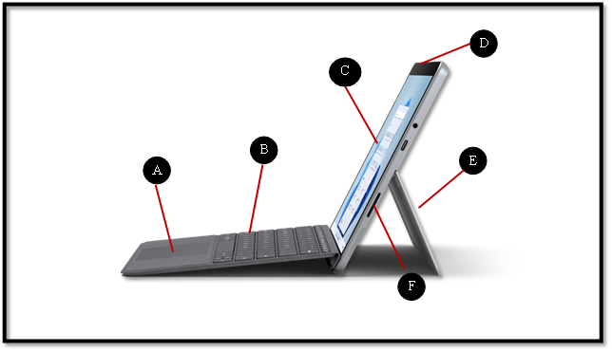
Source: https://www.microsoft.com/en-us/d/surface-go-3/904h27d0cbwn?rtc=1&activetab=pivot:overviewtab
- touchpad or trackpad
- keyboard
- touchscreen
- power button
- kickstand
- charging port

Surface Go Features (Advanced)
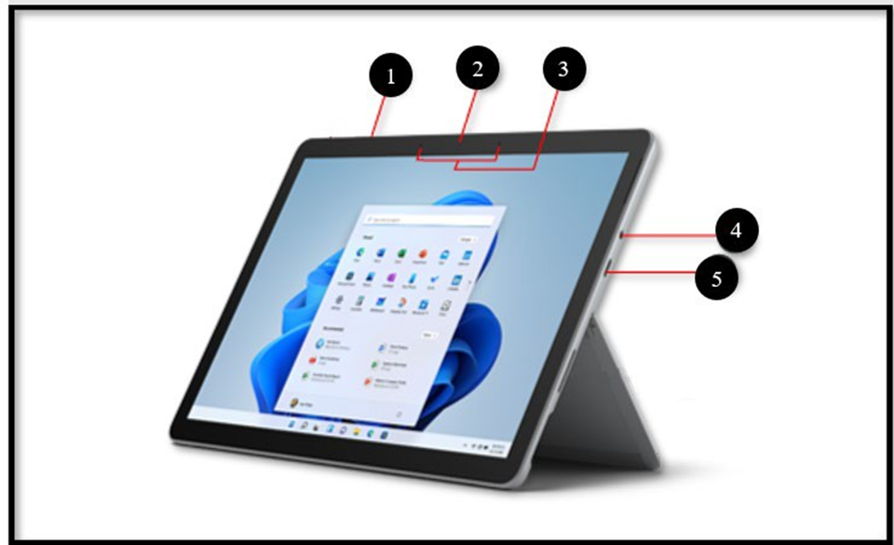
Source: https://support.microsoft.com/en-us/surface/surface-go-3-features-1ef2c926-4de1-46c9-a159-9fcb13992509
- volume
- camera
- microphone
- headphone jack
- USB-C port

