Symbols Keyboard Assessment
Find the letters you need to type the text below:
- daisy@gmail.com
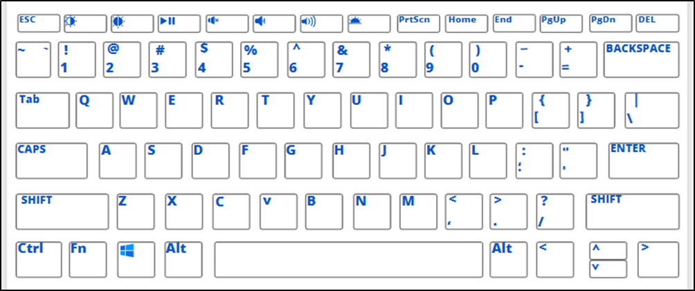
- amazon.com/ebooks
- Hello!
- What?
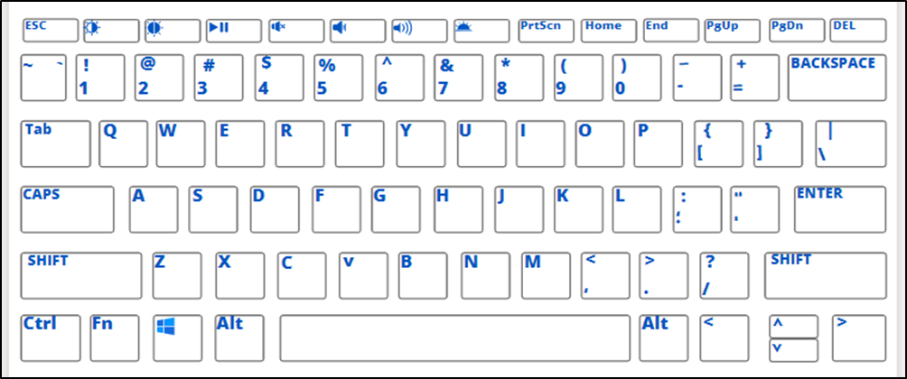
- *Required.
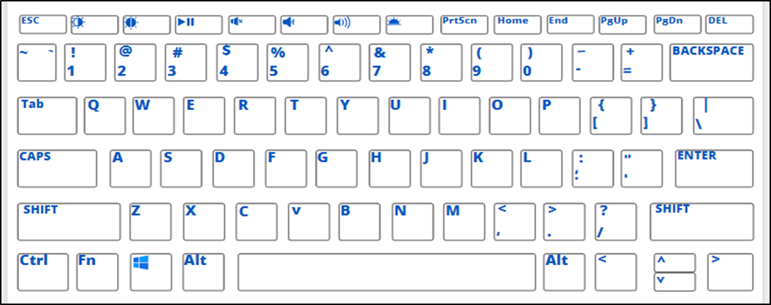
- Hi, I am here.
- $30.00
- #16

