Locating Symbols on the Keyboard
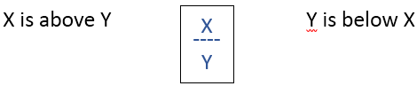
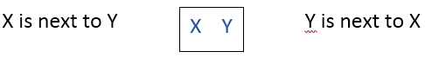
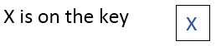

Choose the correct preposition and write it in the sentence.
- The number keys are _______ the letter keys. (above / below)
- The question mark (?) is __________ the shift key. (on / next to)
- The (@) is _______ the number 2 key. (on / next to)
- The comma is ______ the M key. (above / next to)
- The asterisk or star (*) is _______ the number 8 key. (below / on )
- The letter keys are _______ the number keys. (below / above )
- The pound sign (#) is __________ the number 4 key (below / on)
- The exclamation mark (!) is_______ the at symbol (@). (next to / on)
Answer Key: 1. above 2. next to 3. on 4. next to 5. on 6. below 7.on 8. next to

