Capital Letter Keyboard Assessment
Circle the 2 keys you need to make the capital letter.
- T
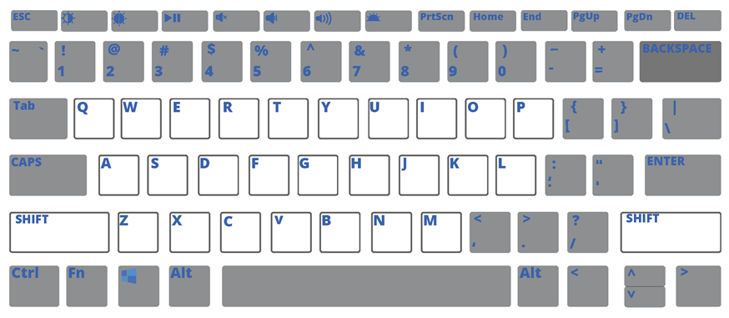
- Y
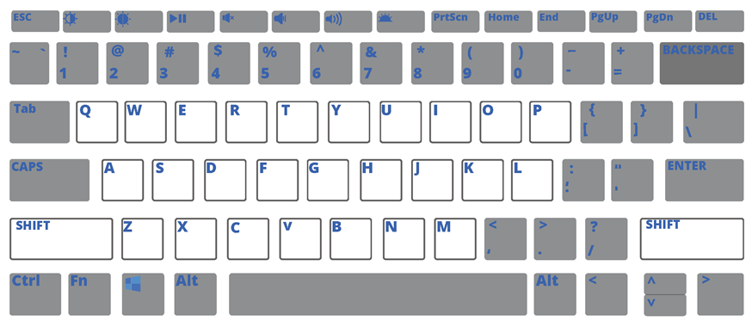
- S
- O
- N

