Capitalize or Not?
Does this word need to be capitalized?
 | boy | □ yes | □ no
 | chicago | □ yes | □ no
 | city | □ yes | □ no
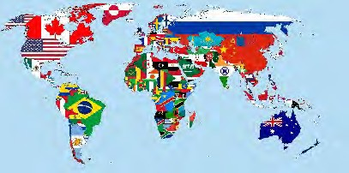 | country | □ yes | □ no
 | girl | □ yes | □ no

 | john | □ yes | □ no
 | mary | □ yes | □ no
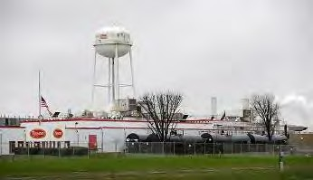 | plant | □ yes | □ no
 | tyson | □ yes | □ no
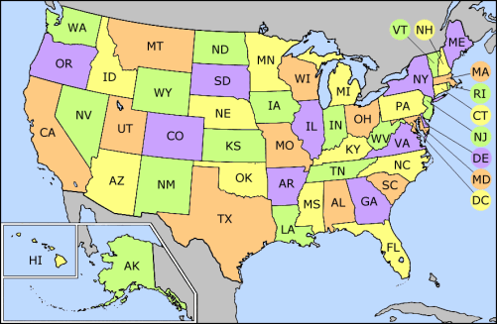 | united states | □ yes | □ no

