Digital Skills Review
Follow the instructions. Tell your teacher when you finish each instruction. Your teacher will check and put a check mark in the box.
Instructions | Teacher Check
- Write down the password you hear. Ask clarifying questions. | Blank cell
Blank cell | Blank cell
- Which text message is scam? A or B? _________  - 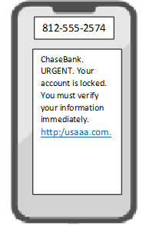  - 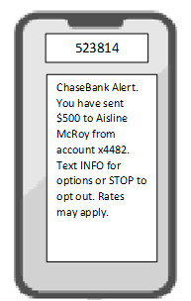 | Blank cell
- Set up your computer and sign in. | Blank cell
- Open Chrome and go to gmail.com | Blank cell
- Sign in to your Gmail account | Blank cell
- Sign out of your Gmail account. | Blank cell
- Find the answer to this question: What is the capital city of Belarusa? | Blank cell
- Close Chrome and use Ctrl/Alt/Delete to sign out. | Blank cell

