What I Learned About Computers
Read some of the things we learned about computers in the class.
How much did you know the FIRST day you came to class?
Mark an X on the number line.
How much do you know TODAY?
Mark an X on the number line.
- I can listen and write down passwords that have lowercase and uppercase letters, numbers, and symbols.
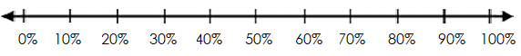
- I can setup and login to a computer.
- I can open Google Chrome from my desktop.
- I can type in gmail.com in the address bar and press the enter key to go to Gmail.
- I can identify text and email messages, pop-up windows, and advertisements that are scam.
- I can sign in to and sign out of my Gmail account.
- I can do an Internet search by typing search terms in the address bar and pressing the enter key.
- I can click on a search result that is a safe website.
- I can look for information on the search result.
- I can use the back arrow on Chrome to go back to my search results.
- I can close Chrome and use Ctrl/Alt/Delete to Sign Out of my computer.

