Where do these words come from?
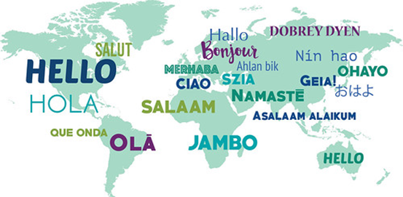
This Photo by Unknown Author is licensed under CC BY
English takes words from many languages.
Use the Internet to find out where these words came from. For your search terms, put each word into this question:
Where does the word ______________ come from?
Draw a line from the word to the language the word is from.
ammonia
cookie
algebra
kindergarten
yogurt
amen
emoji
ketchup
shampoo
orange
Arabic
Chinese
Dutch
Persian
Egyptian
Hindi
German
Hebrew
Japanese
Turkish

