Mary’s Email Scam
Mary is at work.
She checks her email.
She reads this email:
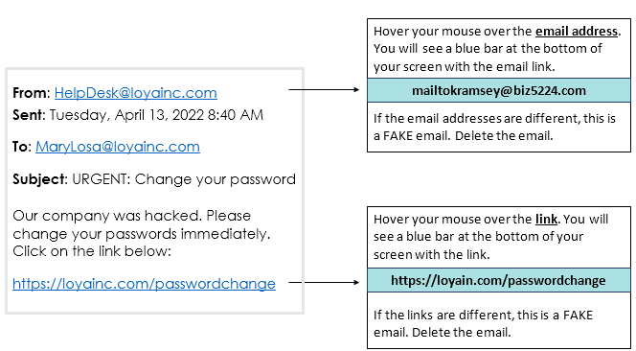
Should Mary click on the link?
Why or why not?

