Creating a Gmail Account
Step 1. Open Chrome. Type gmail.com in the address bar. Press the Enter key on your keyboard.
Step 2. Click on the button that says
“Create Account.”
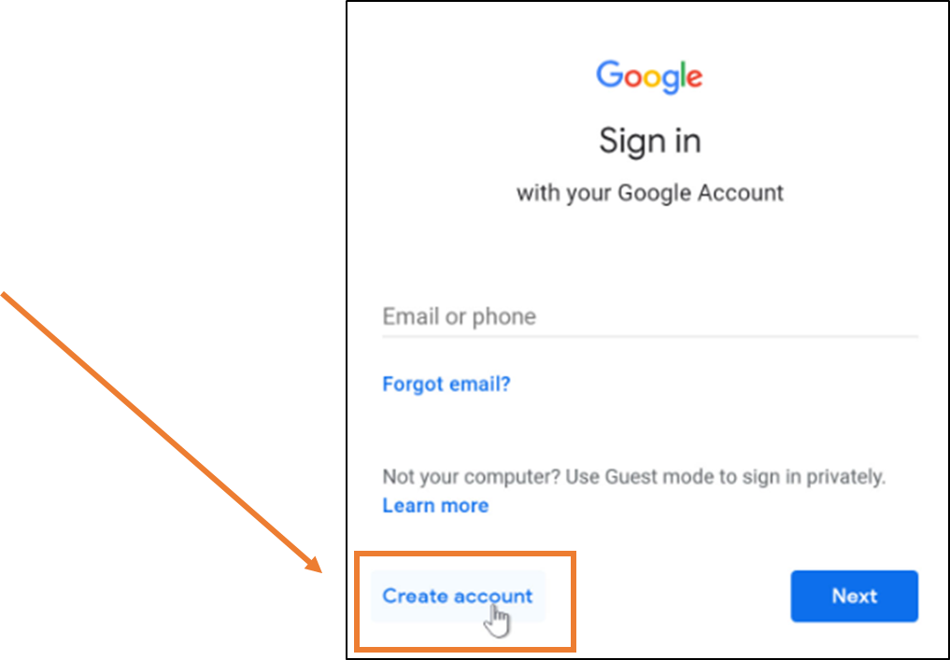

Step 3. Fill in the form.
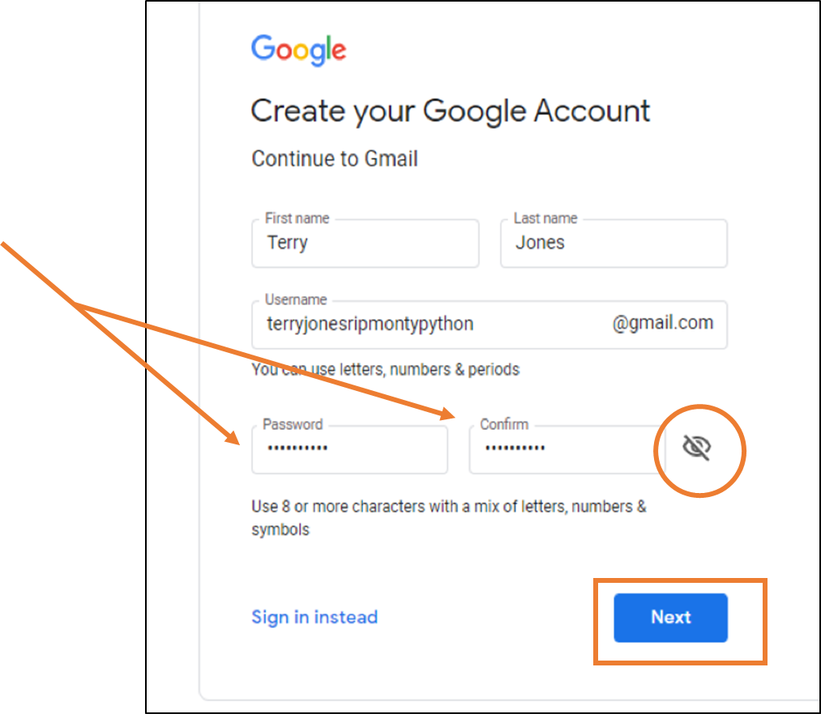
- Use a strong password.
- Type the password 2 times.
- Click on the eye icon to see your password.
- Click the Next button.

Step 4. Enter your phone number to verify. your account. Click on the Next button.
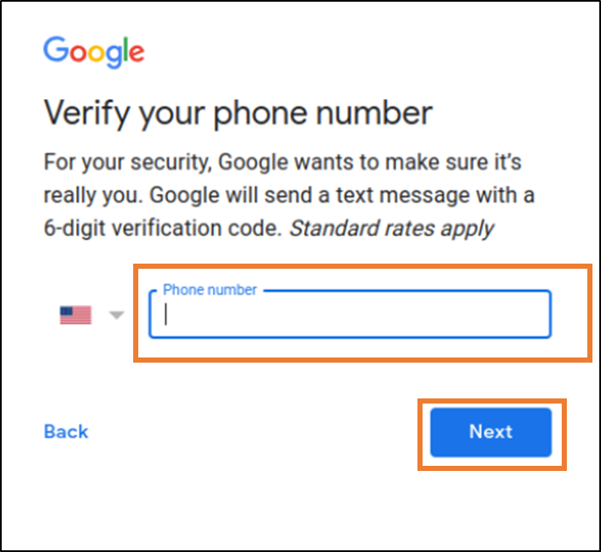
Step 5. Get your text message from
Google. Type your 6-digit code into the box. Click on the Verify button.
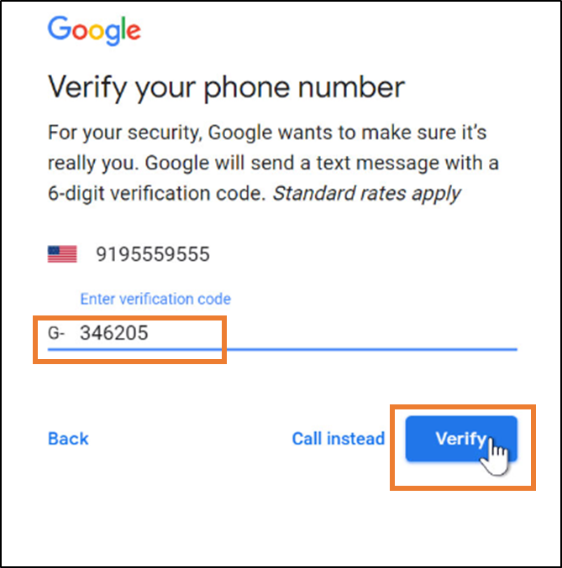

Step 6. Fill out the personal information.
This is to help you if you forget your username or your password.
Step 5. Fill in your Date of Birth and
your Gender. Click the Next button.
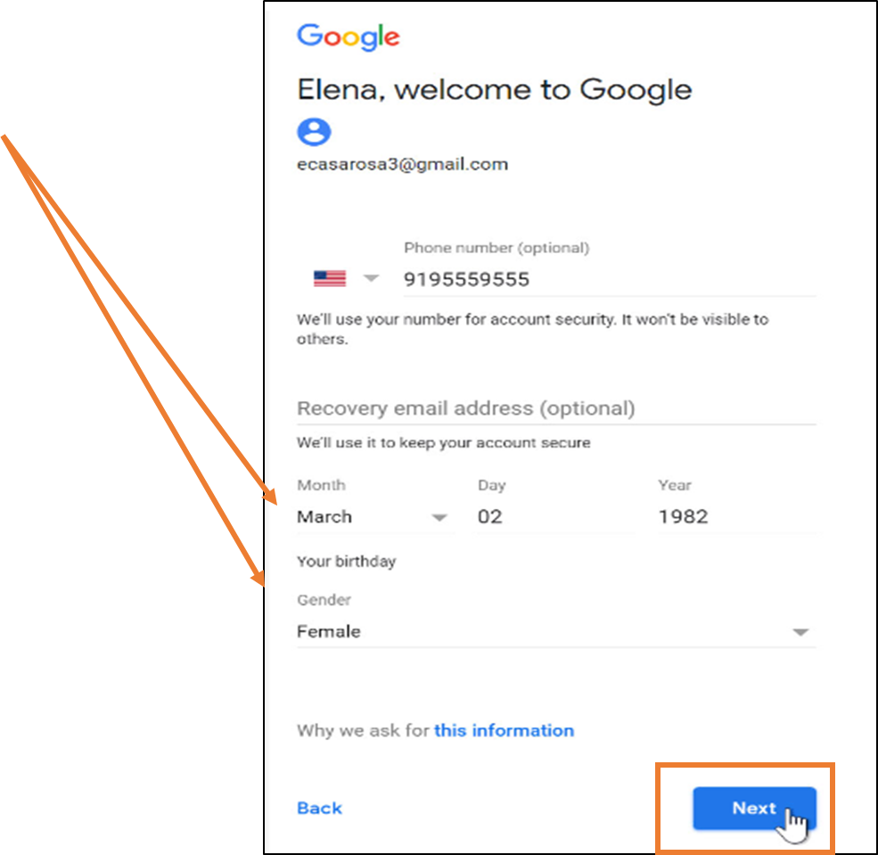
Step 6. Agree to Google’s information. Click the
I Agree button.
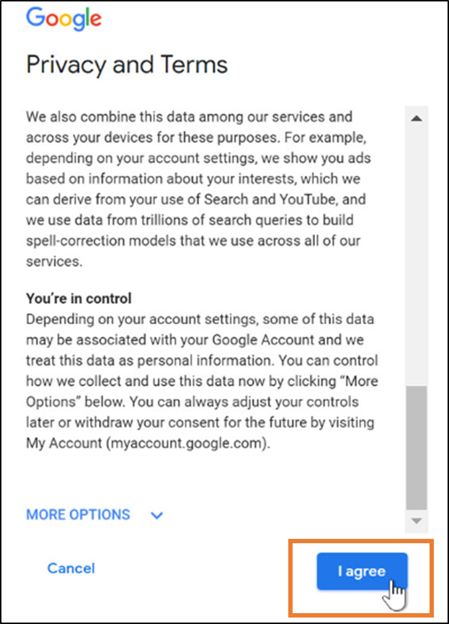

You created your account! Your username is Your_username@gmail.com You are signed in.
Your profile icon is the circle with the Y.
