Resetting your Password
- Go to tinyurl.com/banksimulation
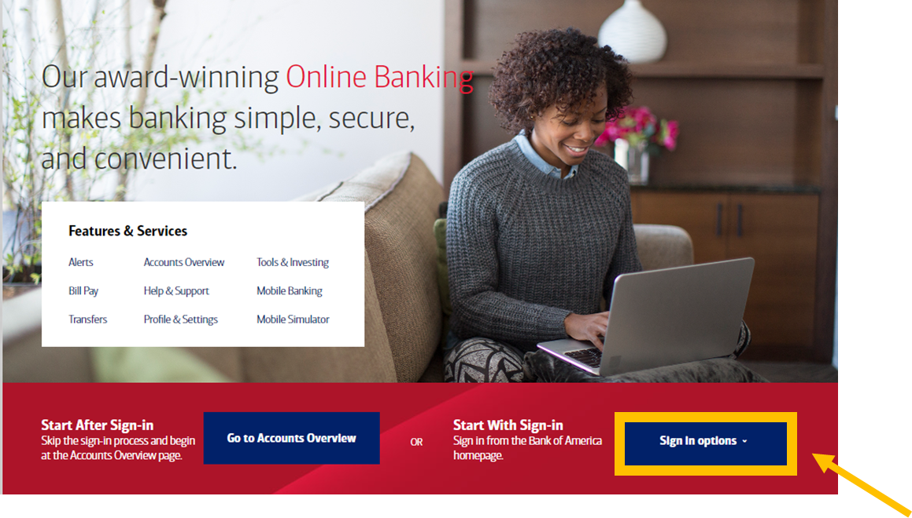
- Click on Sign in options.

- Click on Sign-in Recognized Device.
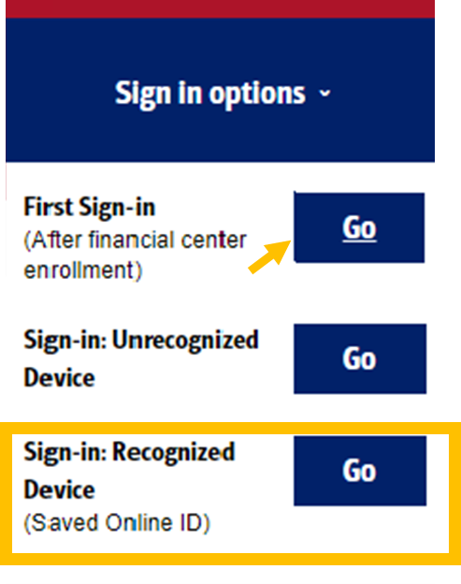
- Click on the Forgot Password link.
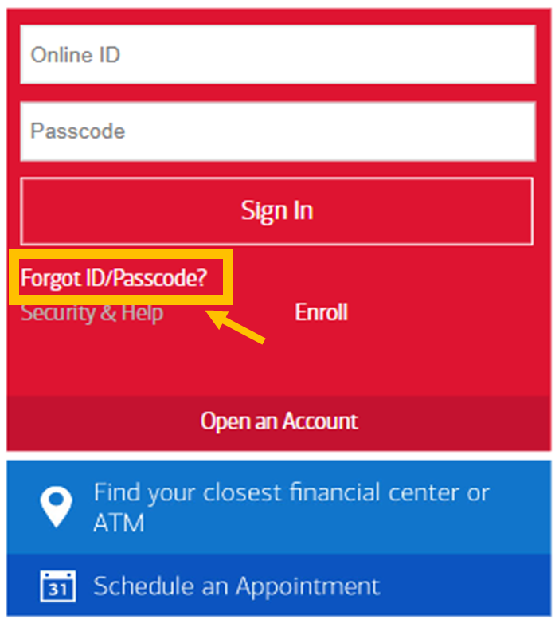

- Click in each text box. Click on Continue.
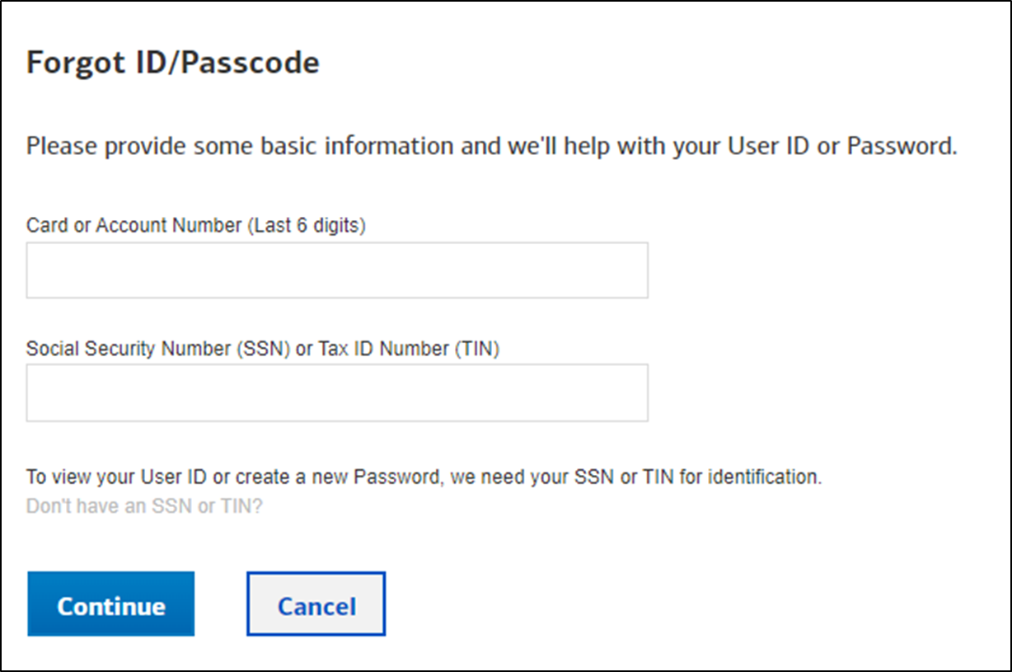
- Click text message and Send Code.
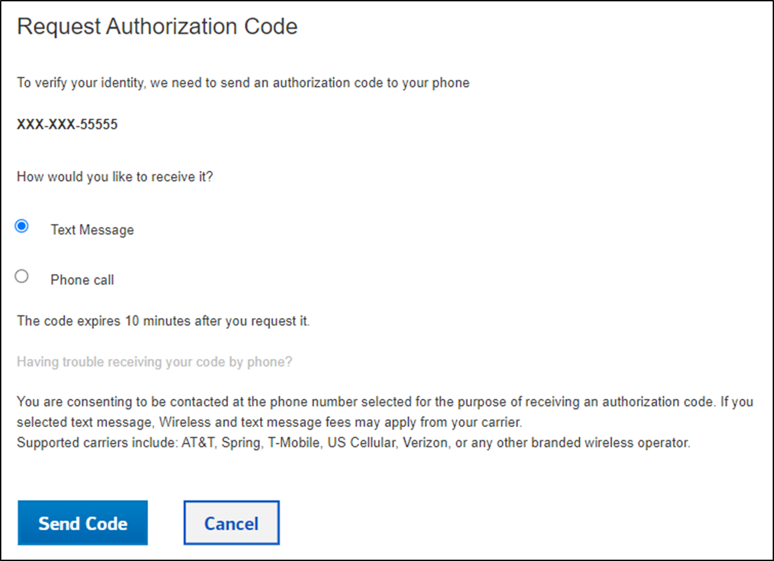

- Click in the Authorization Code box. Click on Continue.
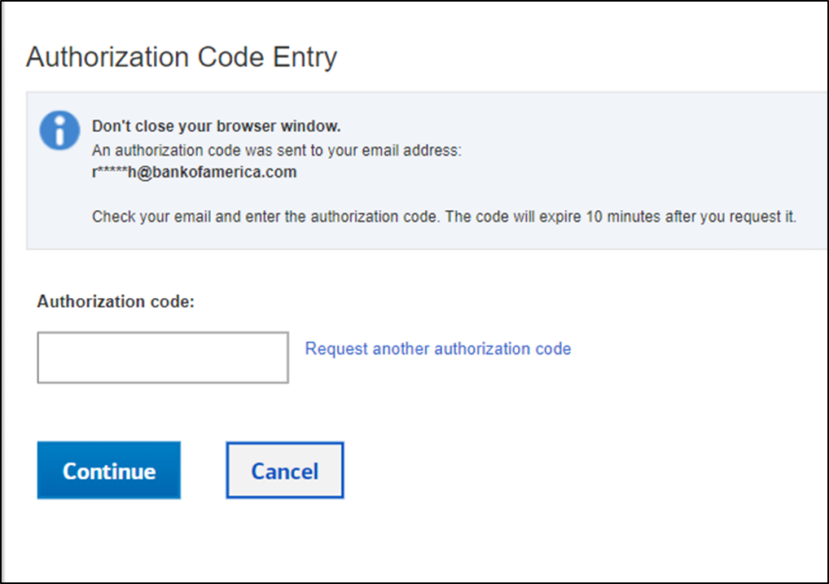

- Click in the boxes. Click on Continue.
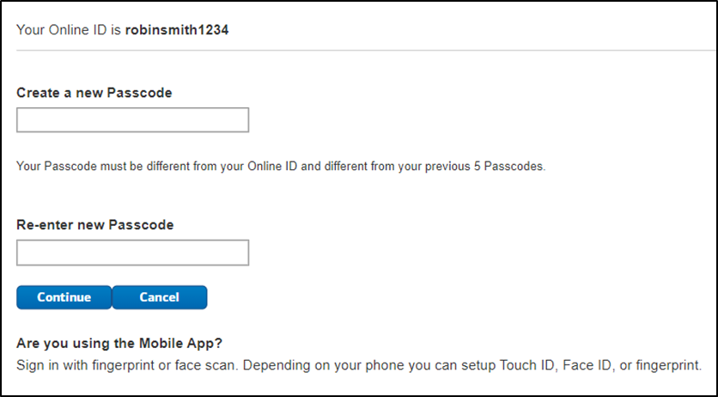
- Read the message.
