Creating a Practice Account
- Go to tinyurl.com/banksimulation.
- Click on Sign in Options.
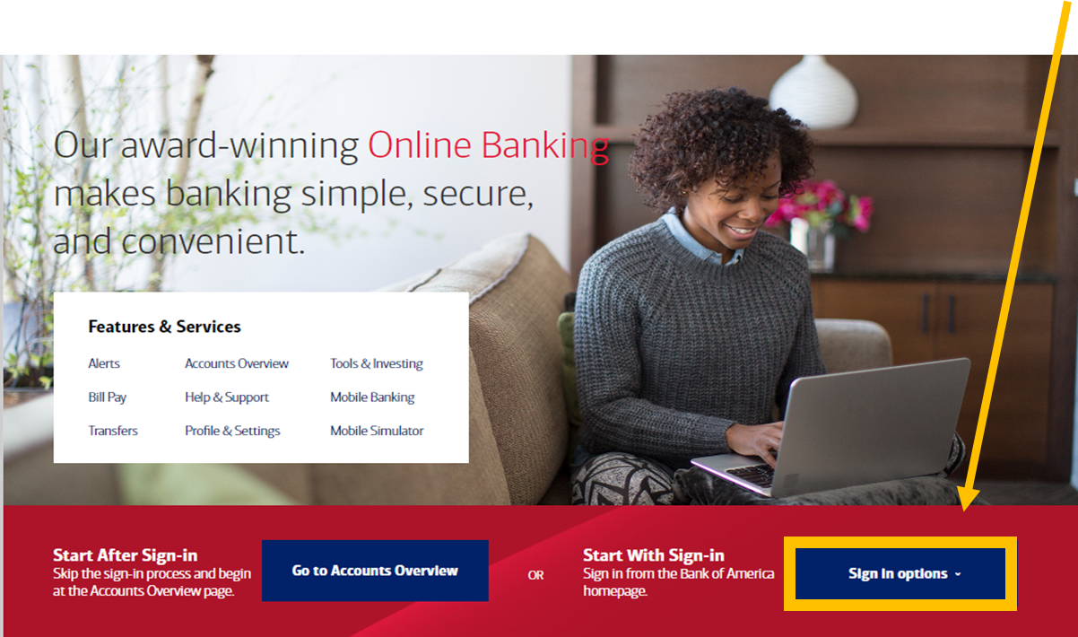

- Click on First Sign-in.
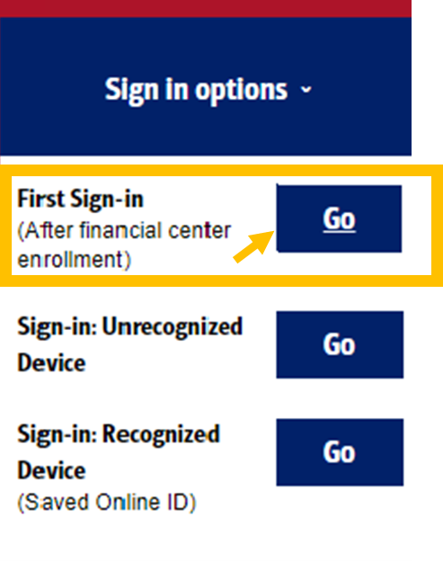
- Click on Enroll.
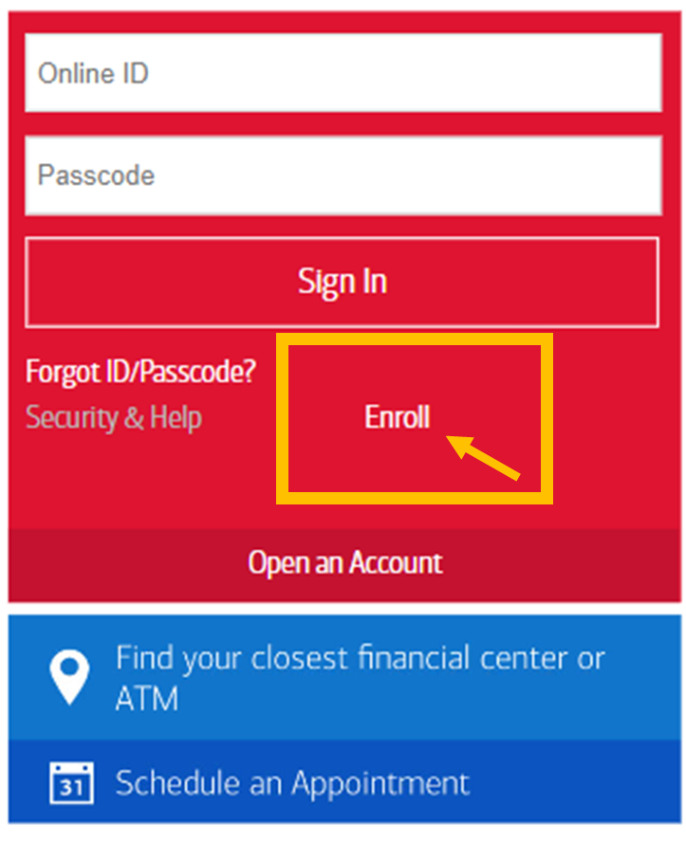

- Click on Text Message or Call Phone.
Click on Send Code.
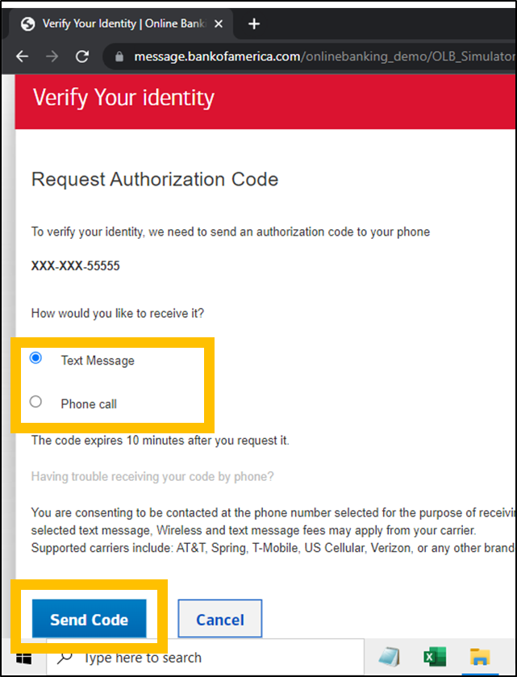
- Enter 123456 for the Authorization code.
Click on Yes or No.
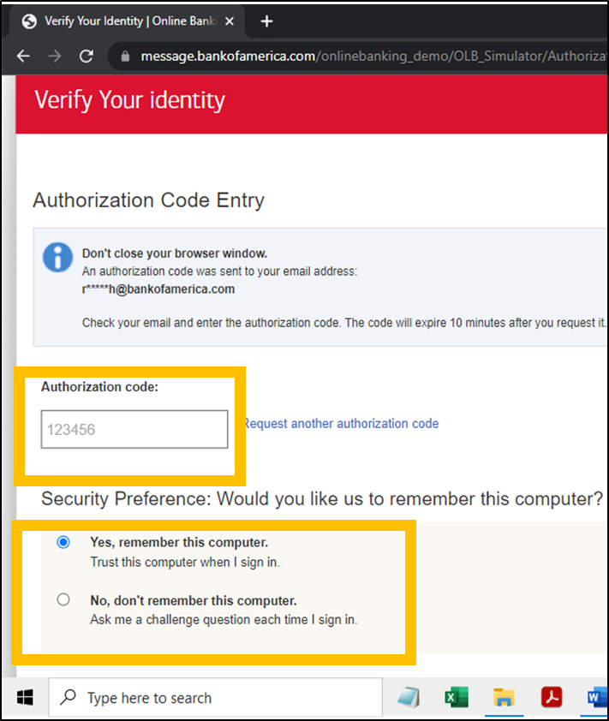

- Click in the box to agree.
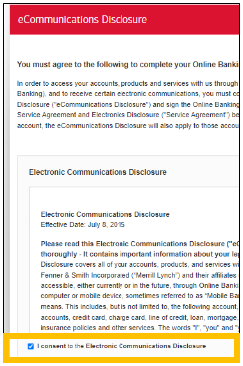
- Click in the box to agree.
Click on Continue
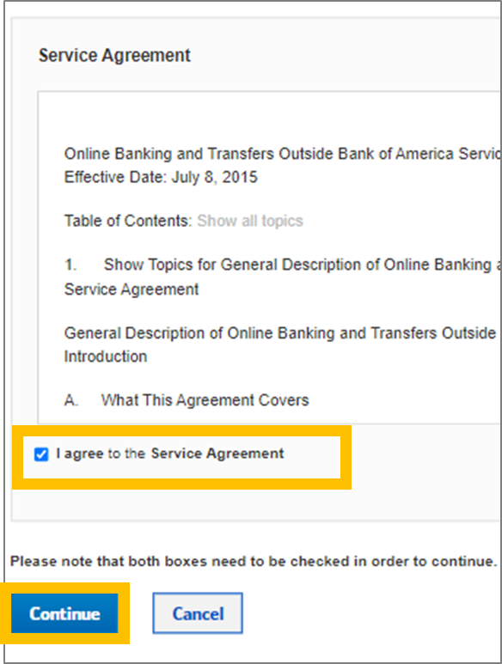

- Choose Remind me Later.
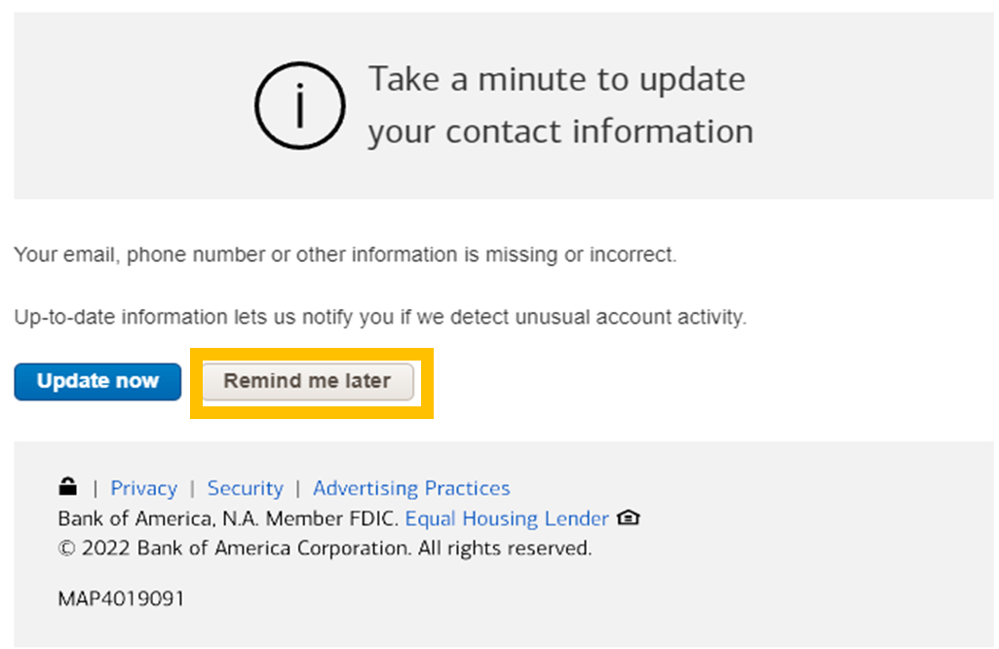

- Congratulations. You are signed in as ROBIN.
