Gina’s Facebook Account Gets Hacked
Gina and Sara are friends. This is Gina. This is Sara.
Sara gets a text message in Facebook. The text message shows Gina’s phone number. The text message shows Gina’s face. But Sara is surprised. Read what happens.
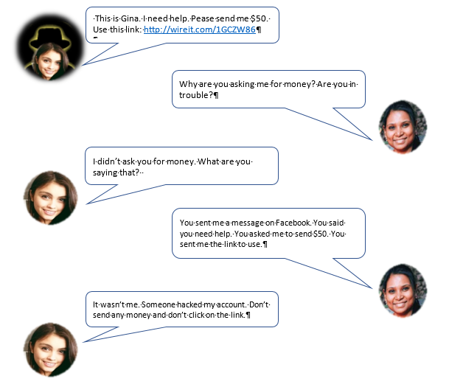

- Comprehension Questions
- What is the name of Gina’s friend?
- What social network platform did they use?
- How much money did “Gina” ask for in the message?
- Did Gina ask for the money?
- Who asked for the money?
- Did Sara send the money?
- Gina’s account was hacked. What does that mean?
- Discussion questions
- Do you know anyone whose account was hacked?
- It was a good idea for Sara to text Gina. Why?
- What should Gina do next?
- What can Gina do so she does not get hacked another time?

