Windows 10 Desktop
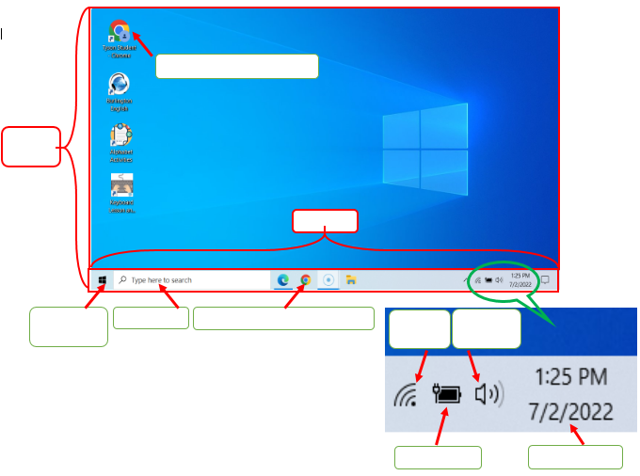
battery icon
Chrome desktop icon
Chrome taskbar icon
main desktop
network icon
Windows search bar
task bar
time and date
volume icon
Windows start menu

