Using Keyboard Shortcuts
Windows + L locks your computer.
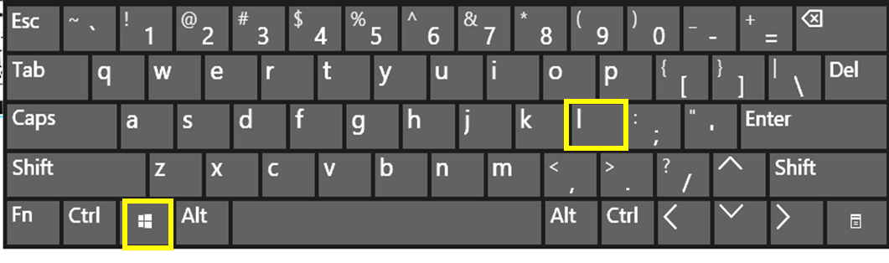
The computer below is locked. You need to click on it with your mouse or swipe up to sign in.

Ctrl-Alt-Del gives you many options like Lock, Sign Out, and the Power icon.
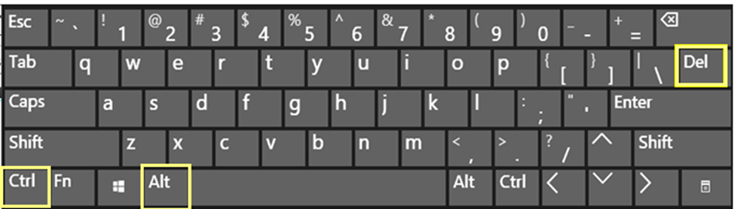
The Lock and the Sign out are words. To Shut down, use the Power icon in in the corner.
