TEAMS 4.3 | Release Date 4.30.19

1. GEDMatch job – add email notification if there is no return file

Update description (Internal Fix):
The “GEDMatch job” looks for a return file from TEA and processes it. If there is no return file, an email notification is sent to our IT developers.

2. Add null check for Community Type to Participant Profile page

Update description (Internal Fix):
When Community Type was changed from required to optional, a ‘null check’ was not added to this field on the participant profile page. This was causing exception errors.

Definitions:

Exceptions
An event which occurs during the execution of a program that disrupts the normal flow of the program’s instructions.

Null Check
Allows a value to be set.

3. Modification needed to HSE extract and potential match – The match process must be revised to expand the number of exact matches

Update description:
A modification has been made to the exact and potential matches to match correct spelling regardless of special characters.

Modification 1:
Automatically verify potential matches whose TEAMS record and TEA record have identical SSNs (regardless of first name, last name or date of birth).

Modification 2:
Match correct spelling regardless of special characters.

Modification 3:
Disregard all spaces, punctuation and case when matching on a Last Name, First Name and Date of birth

4. Modification needed to TxCHSE potential match page

Update description:
TxCHSE Potential matches page has been modified to include additional elements outlined below.
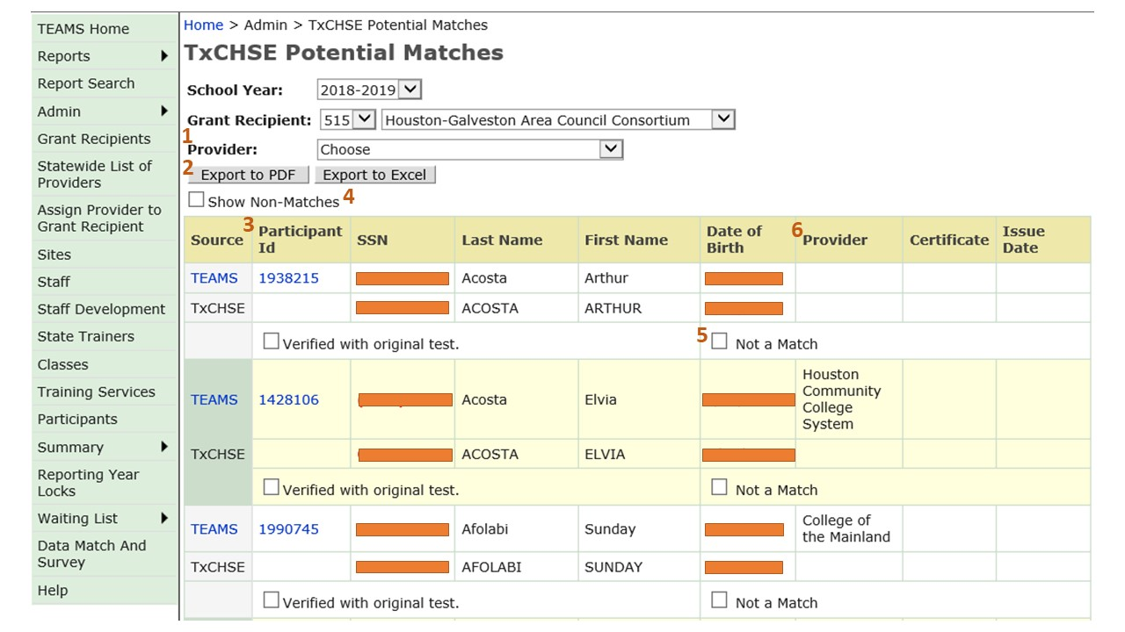

1. Added Provider Filter
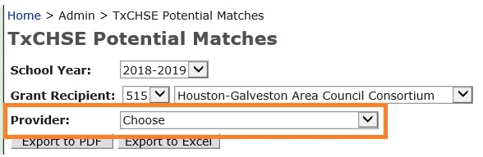

2. Added Export to PDF / Export to Excel feature
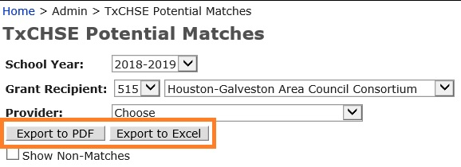

NOTE:
To Protect Personally Identifiable Information (PII), the Social Security Number is not displayed on the PDF or Excel export versions.

3. Added Participant ID
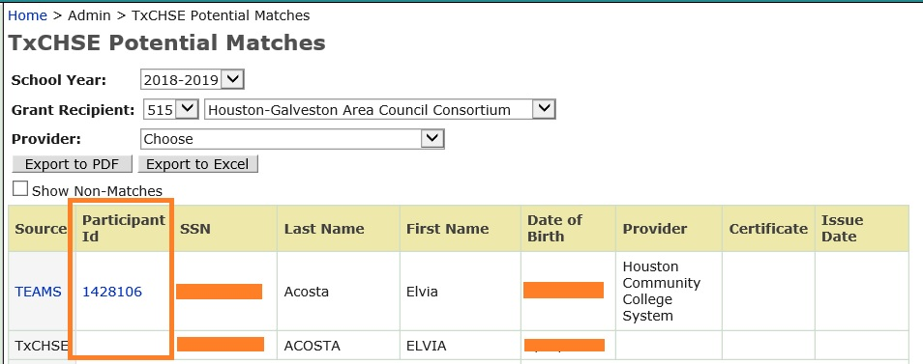

4. Changed ‘Show Hidden’ to ‘Show Non-Matches’
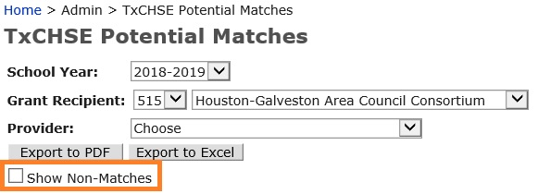

5. Changed ‘Hide’ to ‘Not a Match’
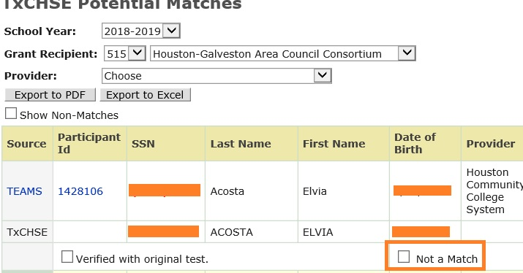

6. Added Provider Column
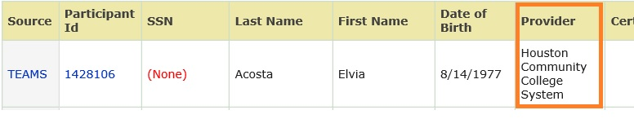

NOTE:
1. The Provider Grantee that appears in the provider column is attached the participant’s last contact hour.
2a. If the participant does not have contact hours in the current program year or the previous program year when the TxCHSE Potential Matches page is opened, they will not appear on the match list. This is true even if they were in the seed file due to having an active profile.
2b. Once the student has contact hours, they will display on the TxCHSE Potential Matches page.

