TEAMS 5.8|Release Date 09.30.2021

ENTERING EDUCATIONAL ENROLLMENT (TYPE 1B MSG) FOR NON-EXITERS

Purpose

TEAMS was modified to prevent users from adding a Measurable Skills Gain (MSG) > Enrollment in Post-Secondary Education (PSE) and business rules was added to determine whether an Educational Enrollment (EE) > Post-Secondary Enrollment should also be saved as an MSG/PSE. A data fix to remove the MSG/PSEs from students whose Date Achieved is <= their Last Service Date +90 days (Exit Flag = Yes).

Business Rules
- Disabled the Measurable Skill Gain Type = Educational Functional Level Gain.
  - Disable the EFL Gain Type = Enrollment in Post-Secondary Education.

- When the user adds an Educational Enrollment/Post-Secondary Education, run the MSGPSE process.

- When the user modifies the EE/PSE, run the MSGPSE process to determine if the MSG/PSE still meets the conditions in Batch Processing updates. If not, display the message, “The Participant has an existing MSG/PSE. Modifying the EE/PSE may change or delete the MSG/PSE. Click on the Continue button to save the change to the EE/PSE. Click on the Cancel button to NOT save the change to the EE/PSE.”

- When the user adds an EE/PSE, automatically insert an End Date after the Start Date is entered according to the following rules:
  - The End Date must default to the end date of the quarter that the Start date is in.
  - Allow the End Date to be changed to any date within the quarter that the Start Date is in.
  - If the End Date is left blank, display the message, “The End Date is required.”

- When the user deletes the EE/PSE, display the message, “The Participant has an existing MSG/PSE. Modifying the EE/PSE may change or delete the MSG/PSE. Click on the Continue button to save the change to the EE/PSE. Click on the Cancel button to NOT save the change to the EE/PSE.”

- Date Fix. TEAMS must insert an End Date into all EEs (all the way back to 01/01/2016) that do not already have one according to business Rule #5.

EDUCATIONAL OUTCOMES

Purpose
Modified Educational Outcomes (EO) to give multiple Grant Recipients (GR) credit for all Measurable Skills Gains (MSG), Credentials, and Educational Enrollments (EE) based on Workforce Innovation and Opportunity Action (WIOA) performance specifications.

Currently, TEAMS displays the GR that entered the EO in the GR column. When the EO is an MSG >
Educational Functional Level (EFL) Gain > Achievement on a Pre/Post Test, it also displays any other GRs that meet the minimum profile/contact hour requirements to receive credit (in the same column separated by a comma). Now, TEAMS must give credit to all GRs that meet the minimum profile requirements for all Eos and remove the contact hour requirements for additional GRs for MSG > EFL Gain > Achievement on a Pre/Post Test.

- For another GR to get credit for an EO, they must have a program year (PY) profile for the Date Achieved (for MSGs and credentials or Start Date (for EE) and a Period of Participation (POP) withing the PY.

  - Note: It is possible, but rare, for a credential/HSE to have a NULL GR from the GedMatch process.

Business Rules
- The date achieved for an MSG must be within the PY profile that the GR is entering it for. For other GRs to get credit for the same MSG, they must also have a PY and contact hours that attributed to the establishment of a period of participation for the date achieved.

- The date achieved for a credential must be within the PY profile that the GR is entering it for OR within one calendar year after the end date of the last PY that the student had a profile for the same credential, they must also have a PY profile for the date achieved.
  - Note: It is possible, but rare, for a credential/HSE to have a NULL GR from the GedMatch process.
- The start date for an EE must be within the PY profile that the GR is entering it for or within one calendar year after the end date of the last PY that the student had a profile for. For other GRs to get credit for the same EE they must also have a PY profile for the start date.

- Determining the additional GRs that get credit for an EO must initially occur at the time the EO is added in EO OR when a profile is added, modified, or deleted.
  - Example 1: GR 501 enters an MSD with Date Achieved = 01/01/2021. TEAMS checks to see if there are any additional GRs with a PY profile for the date achieved. It finds none. Then, GR 502 enters a PY profile. At that time, TEAMS will check to see if there are any Eos (not just the MSG that GR 501 added) that GR 502 can get credit for it.
  - Note: Due to the Defect 207071: For Type 4 MSG, automatically creating profile does not grant the GR credit.

- If the original GR deletes the EO, then it must be deleted for the additional GRs as well.
  - If the user modified the EO, then it must be modified for the additional GRs.
    - Note: The only exception to the Business Rule #4 is when the EO date is changed. In that case, TEAMS must check to see that the original GR and additional GRs are still eligible to get credit for the EO in Educational Outcomes.

- If an MSG is automatically added as a credential or EE (or vice versa), TEAMS must carry over the additional GRs that get credit for the EO.
  - Note: Defect #156008 – GED Matches only be applied to MSG table instead of both MSG and Credential tables when a POP exist – will prevent users from entering an MSG/Enrollment in Post-Secondary Education. Users will enter it as an EE and a new .exe will determine whether or not it should be copied as an MSG.

- Data Fix. Determine additional GRs to give credit to for EOs entered between 07/01/2017 and the TEAMS 5.8 release date if an MSG and 01/01/2016 and the TEAMS release 58 release date if a credential or EE.
  - Note: This will allow GRs to gain credit for as many EOs as possible for PY2020-2021 going forward.
  - For other GRs to get credit for an HSE as a credential, they must have a PY profile for the date achieved OR a profile for the PY prior to the one that the date achieved is in.

GED MATCHES ONLY BEING APPLIED TO MSG TABLE

INSTEAD OF BOTH MSG/CREDENTIAL TABLE WHEN POP EXIST

Purpose

Modified the GED Match process to add HSE’s as credential even if the Date Achieved is not in a Program Year that the student has a profile for and create a data fix to add the missing HSE credentials:
- As of 06/23/2021, TEAMS is missing 101 HSE credentials for PY2019-2020 and 198 HSE credential for PY 2020-2021.
  - Note: This data fix will also include missing HSE credentials for PY2021-2022 between 07/01/2021 and the release of the TEAMS 5.8 on 09/30/2021.

Business Rules
- Data Fix. Insert missing HSE credentials for students for the period between 07/01/2019 and the TEAMS 5.8 release date.
  - Missing HSE credentials are identified as those HSEs that were received in the return file but whose Date Achieved was not in a PY the student had a profile for.
  - Note: Allow multiple Grant Recipients to receive credit for the HSE credentials.

PARTICIPANT NOTES

Purpose

Modified Participant Note to include permissions for all TEAMS roles to Create/Delete/Read/Update.

Prototype Screen – Participants > Participant > Participant Notes

Prototype Screen – Participants > Participant > Participant Note Details

PERIOD OF PARTICIPATION REPORT – EXCEPTION ERROR

Purpose

Modified Period of Participation (POP) report to be enable Profile Variables for options that may have caused an exception error.
Prototype Screen - Home> Reports > Participant > POP > Start/End Date > Expand Participant > Expand Profile Variables

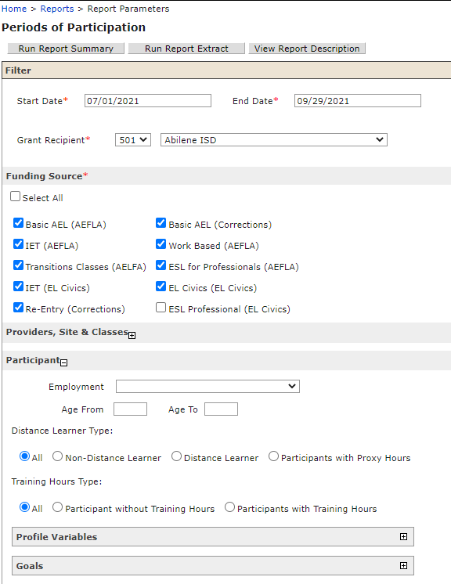

Prototype Screen - Expand Employment and Educational Information > Uncheck the “Select All” for Highest Educational Level Completed > Check Attained Associates/Bachelor/Beyond a Bachelor’s Degrees

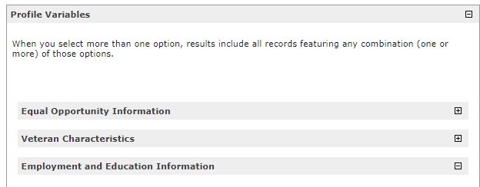

Prototype Screen - Run Summary or Run Extraction Report

