**TEAMS 4.9 |Release Date 3.20.2020**

# Purpose

The new MSG management report provides AEL grant recipients and their sub-providers with a report for determination of measurable skill gain achievement for each participant. The report parameters only include individuals who are in the denominator for a MSG based on current performance methodology.

Report Path: Home> Reports > Participants > MSG Management Report

# Filters and Report Options

The report has familiar filter options including provider, site and class level. It also has participant and goal options as well.

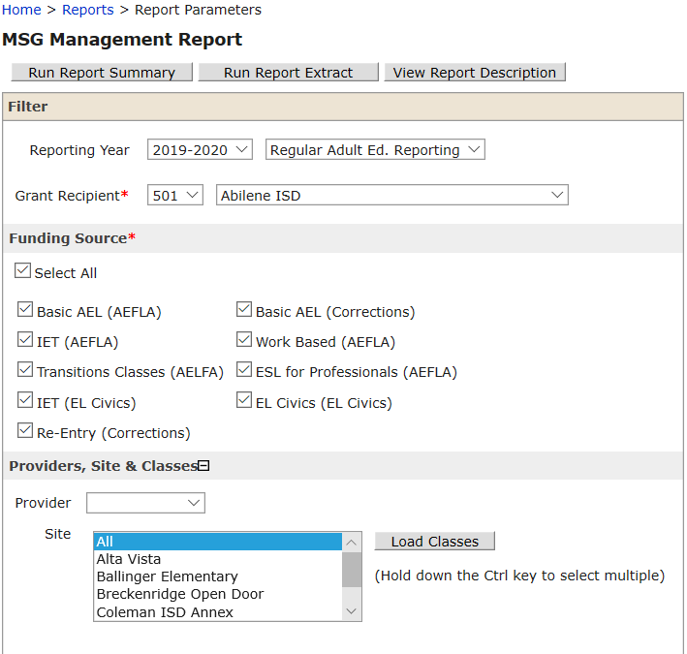

## Screen shot of the MSG management report options including participant options and report options.

## Navigation

1. Click on the Run Report button to execute the report summary with the selected report parameters.
2. Click on the Run Report Extract button to execute the report extract with the selected report parameters.
3. Click on the View Report Description button to navigate to the View Description page.

## Business Rules

1. The following fields and sections have the same functionality as existing reports except where stated otherwise:
   * The Reporting Year must default to the current program year and Regular Adult Ed. Reporting.
   * Grant Recipient
     1. Filter and un-duplicate the grant recipients for those that were active at any time within the selected Reporting Year.

## Funding Source

1. Filter and un-duplicate the following funding sources for those that were active at any time within the selected Reporting Year.
2. Have only the following Funding Sources check boxes default to “Yes.”
   * + 1. 43-EL Civics (AEFLA)
       2. 50-EL Civics (EL Civics)
       3. 23-ESL for Professionals
       4. 37-ESL for Professionals (Local)
       5. 30-ESL for Professionals (TANF)
       6. 17-IET (AEFLA)
       7. 54-IET (Corrections)
       8. 40-IET (EL Civics)
       9. 33-IET (Local)
       10. 27-IET (TANF)
       11. 56-Re-Entry (Corrections)
       12. 55-Transitions (Corrections)
       13. 21-Transitions Classes (AEFLA)
       14. 36-Transitions Classes (Local)
       15. 29-Transitions Classes (TANF)
       16. 19-Work Based (AEFLA)
       17. 34-Work Based (Local)
       18. 31-Work Based (TANF)
       19. 26-Work Based 30hrs (AEFLA)
       20. 35-Work Based 30hrs (Local)
       21. 38-Work Based 30hrs (TANF)
       22. 41-Work-based (EL Civics)
       23. 42-Work-based 30 hours (EL Civics)
       24. 5-Corrections & Institutionalized TWC
       25. 8-Local
       26. 1-Regular Adult Ed (TWC St & Fed)
       27. 3-TANF (TWC State & Federal)
3. Have the Select All check box to default to “No.”

## Providers, Site & Classes

1. Filter and un-duplicate the providers, sites, and classes for those that were active at any time within the selected Reporting Year.

## Participant

1. The following filters are Participant-based.
2. Employment
3. Age
4. Distance Learner Type
5. Training Hours Type
6. Goals are Profile-based.

## Report Options

### Display a check box labeled ‘With Chart’

1. If you select this filter, the Report Summary will produce three bar graphs;
   * + - 1. # of Participants by MSG Type
         2. # of Participants by WFG Type
         3. # of Participants by Gain Type

### Display check box labeled ‘Include SSN’

1. If you select this box, report will display the extract with the SSNs in the following format: ***-***-####. Otherwise, the report will not display the SSN column.

### Display a check box labeled ‘Include Additional Identifying Information’

* + 1. If you select this check box, it will display the following columns on the Extract and populate them. Otherwise, these columns will not display.

1. Driver’s License/State ID #
2. Identity Document #
3. Other Document #
4. DOB
5. Gender
6. Ethnicity
7. American Indian or Alaska Native
8. Asian
9. Black or African American
10. Native Hawaiian or Other Pacific Islander
11. White

Display a check box labeled ‘Include Contact Information’

1. If you check the box, it will display the following columns on the Extract and populate them. Otherwise, do not display the columns.
2. Street Address 1
3. Street Address 2
4. City
5. State
6. Zip Code
7. Mobile Phone
8. Mobile Ext.
9. Home Phone
10. Home Ext.
11. Work Phone
12. Work Ext.
13. E-mail Address

### Order By

* + 1. Default is set for the first DDDW to be Name but users can change it to any order of the following:
       1. Name.
       2. Participant ID.
       3. Pre-Test Date.
       4. Latest Post-Test Date.
       5. Latest EFL Earned Date.

# Images

## Prototype Screen—Reports > Participant > MSG Management Report > Summary

Prototype image of the report summary fo of the MSG management report which included participant Id, name, other document number, Latest MSG earned, Lastest MSG earned date, IET Flag, Latest WFG Earned Type, Latest WFG Earned Date


