TEAMS Release 4.8| Release Date 1.10.2020

First Update: Additional POP Report Filters

Background: Updating POP report
We want to be responsive to AEL providers needs, in doing so, we are adding some additional features to the POP report filters, summary and extract.

Functionality: POP Report Filters
We have added two new filter options to the POP report. These includes “Additional Identifying Information’ and ‘Contact Information’ that you can elect to include on the report extract.
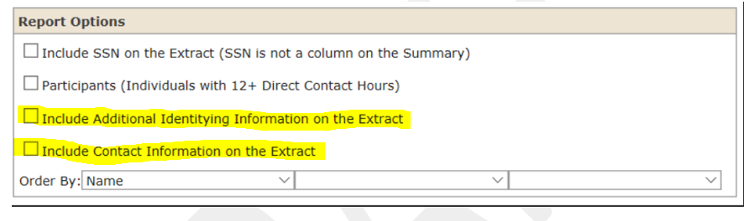

Defining New Filter Options
TEAMS will display a check box labeled ‘Include Additional Identifying Information on the Extract’ and set the default to “No,” but allow it to be changed. If the user selects this radio button, TEAMS will display the report extract populated with the following columns. Otherwise, the columns will not be displayed.
      - Driver’s License/State ID Number
      - Identity Document Number
      - Other Document Number
      - Date of Birth
      - Gender
      - Ethnicity
      - American Indian or Alaska Native
      - Asian
      - Black or African American
      - Native Hawaiian or Other Pacific Islander
      - White

TEAMS will display a check box labeled ‘Include Contact Information on the Extract’ and set the default to “No,” but allow it to be changed. If the user selects this radio button, TEAMS will display the report extract populated with the following columns. Otherwise, the columns will not be displayed.
- Street Address 1
- Street Address 2
- City
- State
- Zip Code
- Mobile Phone
- Mobile Ext.
- Home Phone
- Home Ext.
- Work Phone
- Work Ext.
- E-mail Address

The report description has also been updated to reflect these changes. You can print this out for desk aid use in TEAMS by selecting it in the report options.
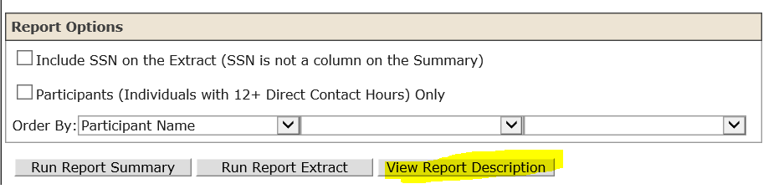

Functionality: POP Report Summary
We have also included the ‘Other Document Number’ to the Report Summary page
POP Report Filters

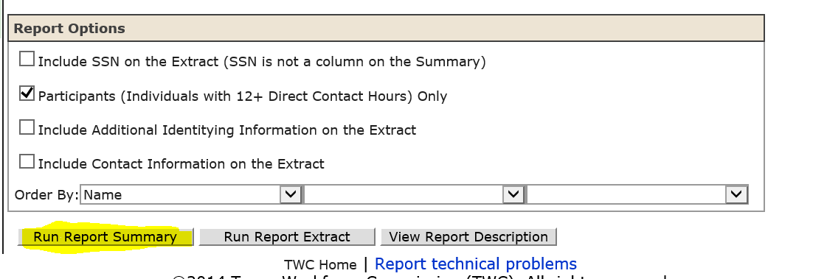
This allows you to quick glance for Locally Assigned numbers on the summary page without pulling the full extract
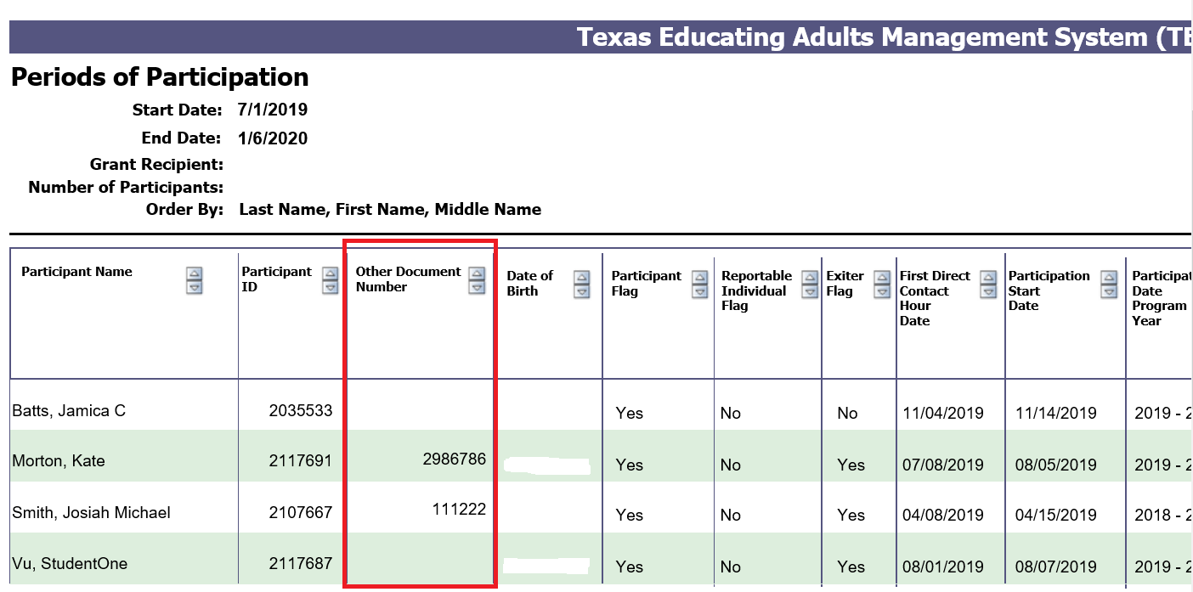

Second Update: Grantee Level Access to Update SSN/DOB/Gender

Background
TEAMS users with write access to the system (Data entry, Supervisor, Director) will now have the ability to fix certain personal information in TEAMS without having to submit a request to TWC state office. In an effort to align to other TWC systems, users with certain restricted permissions will be allowed to update this information in the system and TEAMS will keep a history table on the back end for record keeping of the changes. Write level access users will be able to update SSN/DOB/Gender in TEAMS.

Functionality
TEAMS will still maintain current business rules regarding duplicating information/profiles. This means:
- if the SSN you are trying to use is already being used on another profile, you will not be able to create a duplicate record with that unique number
- you will not have the ability to merge records
- Updating an existing SSN, will require that users also refill/complete the ‘Recorded By’ and ‘Collection Date’ even if this information remains the same. This is to ensure that the person updating the SSN is doing so based on internal review resulting in a need to correct inaccurate information. We understand that in some instances the actual ‘Recorded By’ and ‘Collection Date’ may remain the same based off original intake that was simply keyed incorrectly. We are still requiring that this be re-entered and a new timestamp will occur on the back end in the history tables.
Note: Updating SSN/DOB/Gender will trigger that you update all required personal information per AEL 05-18 and AEL 02-19, only if the individual is a current student and has a PY 19-20 profile. If the individual needing the correction does not have a profile that falls within the parameters of the effective dates of the letters, the Recorded By, Collection Date and Identity Document will not be required. In general terms, what this means if the student is not currently participating (profile and/or class registration and/or contact hours) in the program for this reporting year, the current business rules will not apply.

Third Update: Ability to Add High School Diploma

Background:
During the 86th legislative session, Senate Bill 213 (https://capitol.texas.gov/tlodocs/86R/billtext/pdf/SB00213F.pdf#navpanes=0) was passed that modified the formation of graduation committees and certain individuals who failed to achieve a high school diploma due to certain requirements, could choose to complete requirements and be awarded a high school diploma from their local school district through a graduation committee.
Many AEL grantees have been assisting these individuals with remediation in order to meet requirements that lead to achievement of high diploma through graduation committee approval. We want the ability to capture these as educational outcomes in our statewide data system.

Functionality
TEAMS will now allow you to choose either a high school equivalency or a high school diploma as a manual entry option under the educational outcomes page.
