TEAMS Release 4.6 | Release Date 11.1.19

Background: Aligning TEAMS to Policy Guidance
With the release of AEL Letter 02-19, there are new requirements for requesting additional participant information, such as SSN and/or Driver’s License. This release will also address the collection of identity documents. The collection of participant identity documents is not new, the AEL Letter for requiring identity collection was released in 2018, however the ability to report the collected information in TEAMS is now available and Grantees must ensure that data being collected is entered into the system. Below are some screen shots of what the new page will look like as well as the business rules developed to enhance the system to ensure that the written policy requirements can be reported.

Participant Search
We have updated the participant search function to align to changes in recent policy and simplify the search feature. You will notice that some features have been removed, such as ‘Document Type’ and ‘Document Number’.
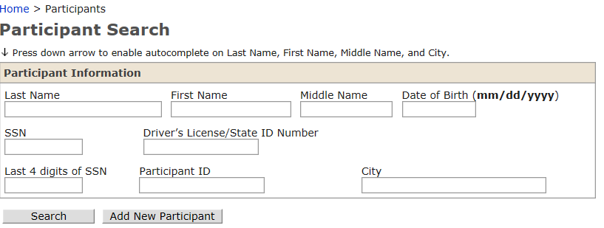

Participant Record Page
The participant record page has been modified to reflect the policy guidance updates in AEL Letter 05-18 and AEL Letter 02-19. Under the participant information section, you will notice a few specific changes to the fields that are required in order to align it to the new guidance. Below is a list of business rules that will help you to navigate the data entry of this information.
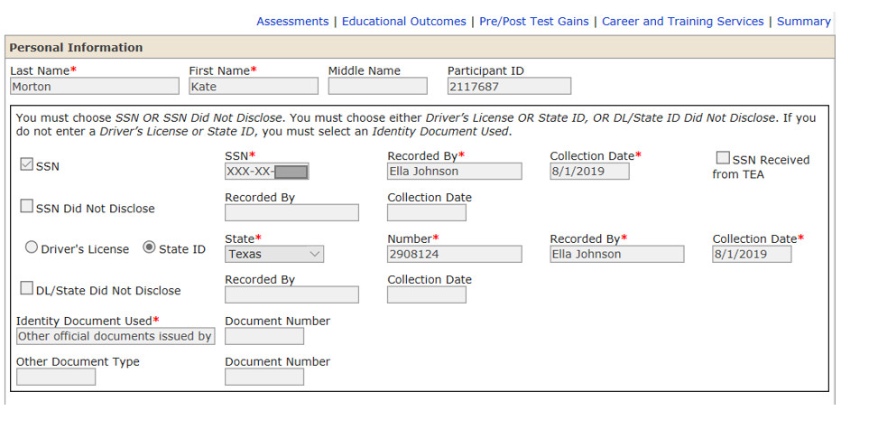

Business Rules Crosswalk Comparison
Below is a crosswalk comparison of IT business rules and user terms that are being implemented with this release.
IT Business Rule | User Terms
1. When a new student is added to TEAMS (or an existing student in TEAMS is modified), the SSN- or SSN Did Not Disclose-related fields are required. If not, display the message, “SSN OR SSN Did Not Disclose required.”  - Display the message, “You must choose SSN OR SSN Did Not Disclose. You must choose either Driver’s License OR State ID, OR DL/State ID Did Not Disclose. If you do not enter a Driver’s License or State ID, you must select an Identity Document Used” if an existing student is:  - Having a profile created  - Being registered for a class  - Having daily contact hours created  - Having monthly contact hours created  2. When a new student is added to TEAMS (or an existing student in TEAMS is modified), the Driver’s License or State ID- or DL/State ID Did Not Disclose-related fields are required. If not, display the message, “Driver’s License OR State ID, OR DL/State ID Did Not Disclose is required.”  - Display the message, “You must choose SSN OR SSN Did Not Disclose. You must choose either Driver’s License OR State ID, OR DL/State ID Did Not Disclose. If you do not enter a Driver’s License or State ID, you must select an Identity Document Used” if an existing student is:  - Having a profile created  - Being registered for a class  - Having daily contact hours created  - Having monthly contact hours created | - Any new student entered in TEAMS must follow protocols in AEL Letter 02-19, thus you must request and record a Social Security Number (SSN), Driver’s License number (DL) or Do Not Disclose for these fields.  If you record a DL number, then it will auto populate that choice as an identity document.  If you do not enter a DL, then you will have to choose and record an identity document.  For existing students without either a SSN or a DL, you will get a reminder message that these are required when you:  - Create a profile  - Register a student for a class  - Enter contact hours  TEAMS will require you to make a selection choice (SSN/DL/Do Not Disclose) for both new or existing students who lack a SSN or a DL
3. If the student currently has an SSN in TEAMS, populate:  - SSN Recorded By = Converted from old format  - SSN Collection Date = (the date that the script for this bug is executed in TEAMS PROD) | 3. If you already collected an SSN for a participant, the other fields previously not required, will auto-populate with default information.  - SSN Recorded By = “Converted from old format”  - SSN Collection Date = “xx/xx/xxx” (the date that the script for this bug is executed in TEAMS PROD)
4. If the student currently has a Document Type and Document Number in TEAMS, convert the data according to Appendix A – Document Type and Document Number Conversion. | - We will automatically convert old information that has been collected based on the new identity documents outlined in AEL Letter 05-18.  The conversion table (Appendix A) is to assist with understanding how we matched old documents to new categories.
5. If an existing SSN whose SSN Received from TEA check box = Yes is changed, set the SSN Received from TEA check box to No AND NULL the existing SSN Recorded By and SSN Collection Date fields. | - We started automatically adding SSN’s into TEAMS if we received the information through our matching process with Texas Education Agency (TEA) that we did not have recorded.  For example, if we completed a data match and all elements/identifiers match except TEA had a SSN and we did not, we would automatically update TEAMS to reflect the most recent data obtained, including SSN.  This rule allows you to change the SSN if you have more updated information. If you update the SSN, the TEA check box will uncheck and the information we received from them will be voided out.
6. the SSN check box is checked, the SSN, SSN Recorded By, and SSM Collection Date fields must be entered as well. If not, display the message(s) “The SSN is required,” and/or “The SSN Recorded By is required,” and/or, “The SSN Collection Date is required.”  - If the SSN Collection Date field is not in a valid MM/DD/YYYY format, display the message “Invalid SSN Collection Date.”  If the SSN is entered, disable the SSN Did Not Disclose Recorded By and SSN Did Not Disclose Collection Date fields. | - If you elect to add an SSN, you must also complete the SSN ‘Recorded By’ and the ‘Collection Date’ field(s). If you do not, you will get an error message letting you know which field still needs to be completed.  If you put in a date that is not in the mm/dd/yyyy format, you will also get an error message requiring that specific format be used.  If you elect to enter the SSN, the ‘SSN Did Not Disclose’ and associated fields will be disable (greyed out).
- If the student does not have an existing SSN in TEAMS, populate:  - SSN Did Not Disclose check box = Yes  - SSN Did Not Disclose Recorded By = Converted from old format  - SSN Did Not Disclose Collection Date = (the date that the script for this bug is executed in TEAMS PROD) | 7. If the student does not have an existing SSN in TEAMS, the system will populate:  - SSN Did Not Disclose check box = Yes  - SSN Did Not Disclose Recorded By = ‘Converted from old format’  - SSN Did Not Disclose Collection Date = (11/1/19)
- If the SSN Did Not Disclose check box is checked, the SSN Did Not Disclose Recorded By and SSN Did Not Disclose Collection Date fields must be entered as well. If not, display the message(s) “The SSN Did Not Disclose Recorded By is required” and/or “The SSN Did Not Disclose Collection Date is required.”  - If the SSN Did Not Disclose Collection Date field is not at in a valid MM/DD/YYYY format, display the message “Invalid SSN Did Not Disclose Collection Date.”  If the SSN Did Not Disclose check box is checked, disable the SSN, SSN Recorded By, and SSN Collection Date fields. | 8. If you elect ‘SSN Did Not Disclose’ check box, you will be required to also enter information into the associated ‘Recorded By’ and ‘Collection Date’ fields as well. If you don’t and try to save the record, it will display an error message.  - The ‘collection date’ field must follow the mm/dd/yyyy format, if not you will get an error.  Once you elect ‘SSN Did Not Disclose’ check box the other fields related to having an SSN will disable (grey out).
- If the Driver’s License or State ID radio button is selected, the Driver’s License/State ID State, Driver’s License/State ID Number, Driver’s License/State ID Recorded By, and Driver’s License/State ID Collection fields must be entered as well. If not, display the message(s) “The Driver’s License/State ID State is required,” and/or “The Driver’s License/State ID State Number is required” and/or “The Driver’s License/State ID Recorded By is required,” and/or “The Driver’s License/State ID State Collection Date is required.”  - If the Driver’s License or State ID Collection Date field is not at in a valid MM/DD/YYYY format, display the message “Invalid Driver’s License or State ID Collection Date.”  - If the Driver’s License or State ID radio button is selected, disable the DL/State ID Did Not Disclose check box and the DL/State ID Did Not Disclose Recorded By and DL/State ID Did Not Disclose Collection date fields. | 9. If the DL or State ID button is selected, you must enter all the other associated fields as well. If you do not and try to save it, you will get an error message indicating which field you did not enter.  - If the DL or State ID collection date is not in a mm/dd/yyyy format—you will get an error message  - If you elect to enter a DL/State ID, then the ‘Did Not Disclose’ option and all associated fields will be disable (greyed out)
- If the student does not have an existing Driver’s License or State ID in TEAMS, populate:  - DL/State ID Did Not Disclose = Yes  - DL/State ID Did Not Disclose Recorded By = Converted from old format  DL/State ID Did Not Disclose Collection Date = (the date that the script for this bug is executed in TEAMS PROD) | 10. During conversion, if the student does not have an existing DL/State ID, the system will automatically choose:  - DL/State ID ‘Did Not Disclose’  - DL/State ID ‘Did Not Disclose’ ‘Recorded By’ field will display “Converted From Old Format”  DL/State ID ‘Collection Date’ will display 11/1/19 as the default date of the conversion
- If the DL/State ID Did Not Disclose check box is checked, the DL/State ID Did Not Disclose Recorded By and DL/State ID Did Not Disclose Collection Date fields must be entered as well. If not, display the message(s) “The DL/State ID Did Not Disclose Recorded By is required” and/or “The DL/State ID Did Not Disclose Collection Date is required.”  - If the DL/State ID Did Not Disclose Collection Date field is not at in a valid MM/DD/YYYY format, display the message “Invalid DL/State ID Did Not Disclose Collection Date.”  - If the DL/State ID Did Not Disclose check box is checked, disable the Driver’s License/State ID State, Driver’s License/State ID Number, Driver’s License/State ID Recorded By, and Driver’s License/State ID Collection Date fields. | 11. If choose the DL/State ID ‘Did Not Disclose’ option then all associated fields must be entered as well. If you don’t, when you go to save it, you will get an error message that identifies which associated fields are missing.  - You must use a mm/dd/yyyy format for dates, if not you will get an error message  - If you choose DL/State ID ‘Did Not Disclose’ options, then DL/State ID fields will be disabled (greyed out)
- When a new student is added to TEAMS (or an existing student in TEAMS is modified), the Identity Document Used is a required field. If it is not selected, display the message, “Identity Document is required.”  - Display the message, “You must choose SSN OR SSN Did Not Disclose. You must choose either Driver’s License OR State ID, OR DL/State ID Did Not Disclose. If you do not enter a Driver’s License or State ID, you must select an Identity Document Used” if an existing student is:  - Having a profile created  - Being registered for a class  - Having daily contact hours created  - Having monthly contact hours created  Note: Neither the Document Number nor the Upload Identity Document fields are required. | 12. When a new student is added to TEAMS or an existing student in TEAMS is modified, the ‘Identity Document Used’ is a required field. If you do not select something from the drop box, TEAMS will display an error message.  - If you do not have an identity document that matches the conversion table below, you will have to enter one for existing students if they are continuing in the program. TEAMS recognizes these commands as someone who is ‘continuing’:  - Having a profile created  - Registering for a class  - Contact hours being entered  Note: While the above are required, neither the Document Number nor the Upload Identity Document fields are required
- The Identity Document file must be in one of the following formats - .pdf, .doc, .png, .bmp, and .gif. If the user attempts to upload a file that is not in an allowable format, display the message, “The file that you are attempting to upload is not in an acceptable format. Please save it with one of the following extensions - .pdf, .doc, .png, .jpg, .bmp, or .gif.”  - Display the following message if the user attempts to upload an Identity Document file when there is already an existing one, “Uploading this file will replace the existing file, so that you will not be able to view or download it. Are you sure you want to continue?” | 13. If you choose to upload the identity document, then it must be in one of the following formats: pdf, .doc, .png, .bmp, and .gif.  If you try to upload a non-compatible format, you will get an error message  14. If you try upload a document file when there is already an existing one, you will get a message letting you know that you will be replacing the document that is currently in the system
- Neither the Other Document Type nor the Document Number fields are required. | 15. The ‘Other Document Type’ and associated fields are at your discretion for local use and are not required
- All the new fields will be added to the export feature for the Participant’s profile | 16. All the new fields will be added to the export feature for the Participant’s profile

Appendix A – Document Type and Document Number Conversion
Document Type Currently in TEAMS | Convert to | Identity Document Used | (Identity)  Document Number | Driver’s License (DL) | (DL) State | (DL) Number | (DL) Recorded By | (DL) Collection Date
MMHR ID | => | Other official documents issued by a federal, state, or local government agency | Populate from the Document Number currently in TEAMS
Correctional Facility ID | => | Other official documents issued by a federal, state, or local government agency | Populate from the Document Number currently in TEAMS
State Issued ID/TX Drivers License | => | Federal, state, or local government identification card | Populate from the Document Number currently in TEAMS | Select the Driver’s License radio button | Select Texas | Populate from the Document Number currently in TEAMS | Populate with “Converted from the old format” | Populate with (the date that the script for this bug is executed in TEAMS PROD)
Visa/Passport | => | Passport | Populate from the Document Number currently in TEAMS
Voter Registration | => | Other official documents issued by a federal, state, or local government agency | Populate from the Document Number currently in TEAMS
Amnesty – Employment Authorization | => | Other official documents issued by a federal, state, or local government agency | Populate from the Document Number currently in TEAMS
Amnesty – Temporary Relief | => | Other official documents issued by a federal, state, or local government agency | Populate from the Document Number currently in TEAMS
Amnesty – Resident Alien | => | Other official documents issued by a federal, state, or local government agency | Populate from the Document Number currently in TEAMS
Resident Alien | => | Other official documents issued by a federal, state, or local government agency | Populate from the Document Number currently in TEAMS
Employment Authorization | => | Other official documents issued by a federal, state, or local government agency | Populate from the Document Number currently in TEAMS
Political Asylum | => | Other official documents issued by a federal, state, or local government agency | Populate from the Document Number currently in TEAMS
Other I.N.S. Forms | => | Other official documents issued by a federal, state, or local government agency | Populate from the Document Number currently in TEAMS
TANF/Choices Referral | => | Public assistance / social service records | Populate from the Document Number currently in TEAMS
Locally Assigned*
GED Generated Number**
*Note 1: If the Document Type that is currently in TEAMS = Locally Assigned, populate:
- Other Document Type = Locally Assigned
- Document Number = Document Number
**Note 2: If the Document Type that is currently in TEAMS = GED Generated Number, populate:
- Other Document Type = GED Generated Number
- Document Number = Document Number

