TEAMS 4.2 | Release Date 3.29.19

## 1. Period of Participation Calculation

### Update Description

The Period of Participation calculation has been updated so that a career service or assessment test no longer extends a Period of participation.

## 2. Exclusionary Reasons

### Update Description

The update to exclusionary reasons includes multiple areas within TEAMS. Their respective updates are outlined below.

#### Business Rules:

All Exclusionary Reasons must be entered prior to the exit date status flag becoming “Yes”. This means that a Grantee has the Last Service Date + 90 days to enter an applicable Exclusionary Reason.

If you fail to enter an Exclusionary Reason during this time frame and later discover an Exclusionary Reason should have been applied, you will need to send a request to [AELTA@twc.state.tx.us](mailto:AELTA@twc.state.tx.us).

**The Request should include:**

* Participant ID number
* Allowable Exclusionary Reason
* Start and End Date
* Source Documentation

#### A. Profile Page

The profile page has been modified to remove the Exclusionary Reason section including the heading, exclusionary reasons and the Levels Complete Fields in both exit mode and the view mode.

##### Image 1/6 – Screenshot of the new profile section where Exclusionary Reason were previous located

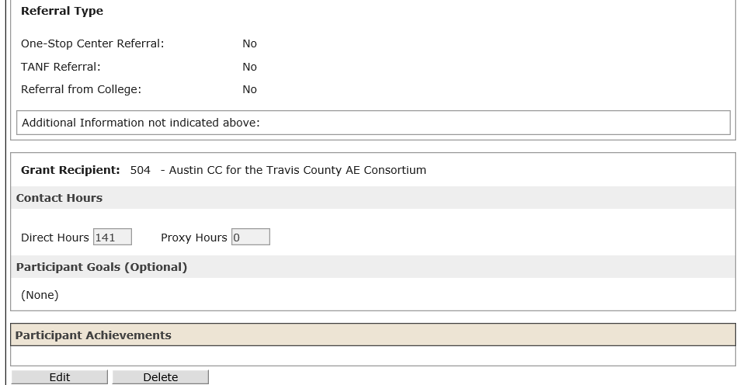

#### B. .PDF Profile Printout

The .PDF Profile printout page no longer includes the exclusionary reasons section including the heading, exclusionary reasons field and the levels completed field.

##### Image 2/6 – Screenshot of .PDF printout of the Participant profile screen where Exclusionary Reason was previous located

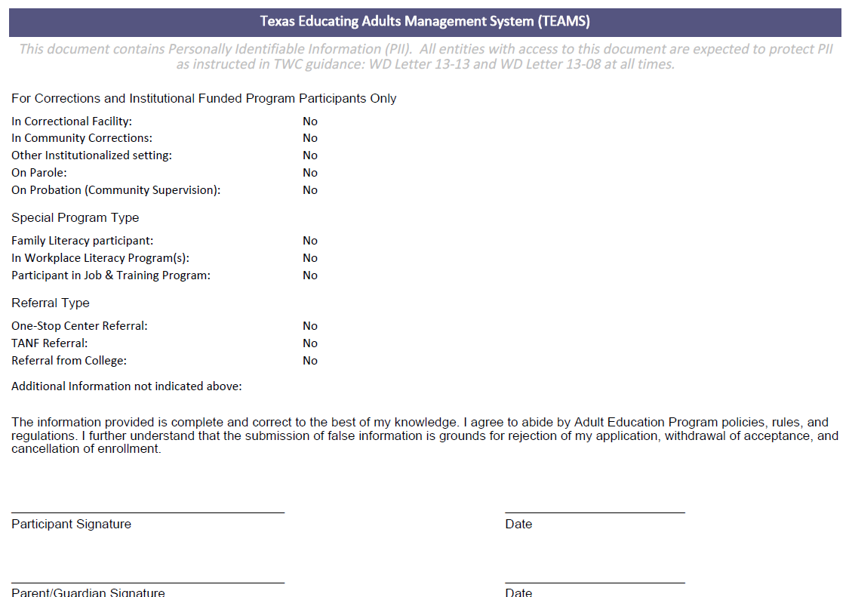

#### C. .XLSX Profile Printout

The .XLSX Profile printout page no longer includes the exclusionary reasons section including the heading, exclusionary reasons field and the levels completed field.

##### Image 3/6 – Screenshot of .XLSX printout of the Participant profile screen where Exclusionary Reason was previous located

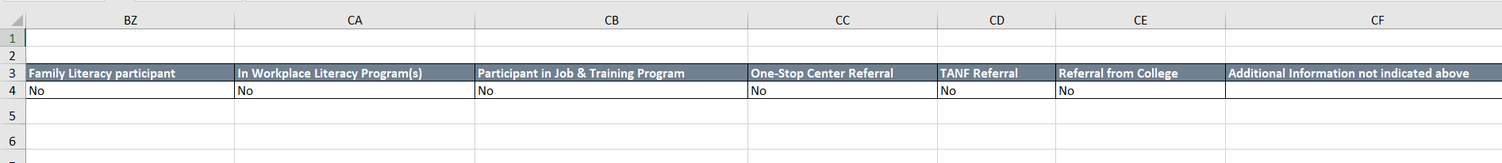

#### D. Participant Page

The Exclusionary Reason section is now included on the Participant page within the Periods of Participation section

##### User Functionality Update

To enter an exclusionary reason, click on the hyperlink below the ‘Exclusionary Reason’ Section of the Periods of participation table of the Participant Profile Screen (pictured below)

##### Image 4/6 – View of participant Profile Exclusionary Reason section when no exclusionary reason is entered.

**NOTE**: Exclusionary reason defaults to ‘No’ for all participants  
**NOTE**: Deceased exclusionary reason Start and End dates default to start date

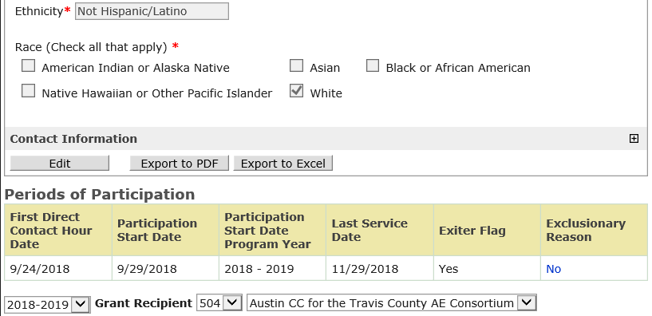

Click Here to Navigate to the Exclusionary Reasons Screen

#### E. Exclusionary Reason Screen (NEW)

The Exclusionary Reason page has been created to capture the data for the Exclusionary Reason field.

##### User Functionality Update

Enter a new exclusionary reason or edit by selecting the Edit button and updating the necessary information including source documentation attachment.

###### Additional Information

**A.** If the Last Service Date has been updated since the Exclusionary Reason was entered (because contact hours have been added or deleted), the Exclusionary Reason End Date will be changed to the updated Last Service Date + 90 days.

**B.** If contact hours have been deleted and the updated Last Service Date = 90 days is less than the existing Exclusionary Reason Start Date, the Exclusionary Reason will be set to ‘No’.

**C.** If enough contact hours have been deleted to change the Participant into a Reportable Individual, the existing Exclusionary Reason will be deleted.

**D.** A user cannot modify/ delete an exclusionary reason unless they are assigned to the same grant recipient of the user that originally added the exclusionary reason.

**E.** A planned gap in service cannot be entered for a period of participation that already has an exclusionary reason.

##### Image 5/6 – Exclusionary Reason Screen

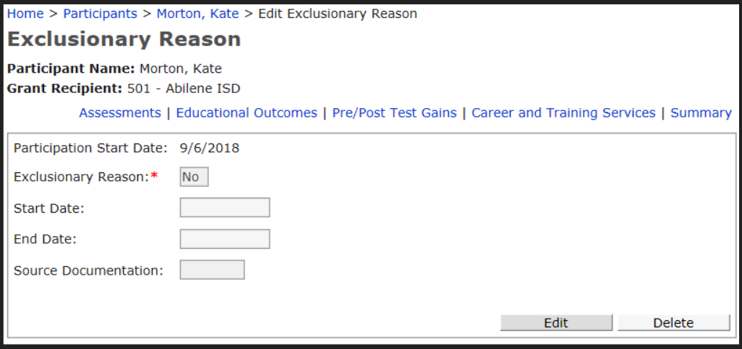

Click Here to Edit or update Exclusionary Reason information

**1. Click the drop-down arrow to select the Exclusionary Reason type  
* Exclusionary Reason Drop-down values are outlined below**

**2. Enter the start date of the exclusionary reason**

**3. The end date will default to the Last Service Date + 90 days**

**4. Select the drop-down menu to enter the type of source documentation to be uploaded**

**5. Click on the ‘browse’ button to select the document to upload**

**6. Select the ‘save’ button to accept changes**

##### Image 6/6 – Editable version of Exclusionary Reason Screen

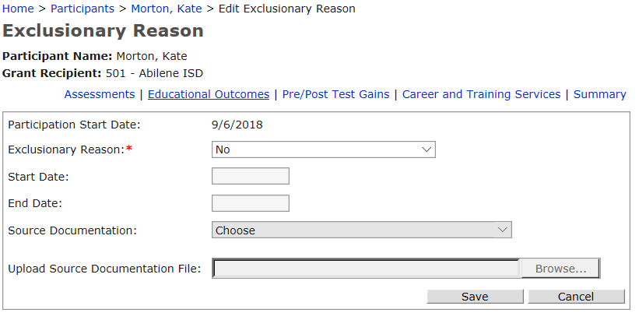

**4**

**1**

**3**

**2**

**6**

**5**

**NOTE**: Source documentation can be uploaded to the Exclusionary Reason screen

The source documentation file must be in one of the following formats - .pdf, .doc, .png, .bmp, and .gif.

#### F. Exclusionary Reason Drop Down Menu Values

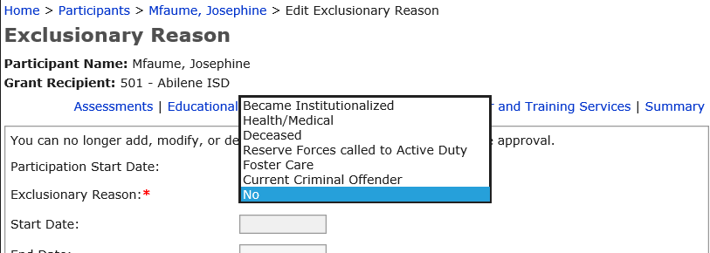

#### Became Institutionalized

The participant exits the program because he or she has become incarcerated in a correctional institution or has become a resident of an institution or facility providing 24-hour support such as a hospital or treatment center while receiving services as a participant.   
  
**Note:** This exclusion differs from theexclusionof participants funded under Section 225 in that those participants are **incarcerated at the onset** of AEL services whereas this exclusion applies to participants **who become incarcerated** during services.

#### Health/ Medical

The participant exits the program because of medical treatment and that treatment is expected to last longer than 90 days and precludes entry into unsubsidized employment or continued participation in the program.

#### Deceased

The participant is deceased.

#### Reserve Forces called to Active Duty

The participant exits the program because the participant is a member of the National Guard or other reserve military unit of the armed forces and is called to active duty for at least 90 days.

#### Foster Care

**Dot not Use** – This will be updated in a future TEAMS release

#### Current Criminal Offender

Participants who are **incarcerated at the onset** of AEL services.

## 3. TABE 11/12 Participant Testing Hours

### Update Description

All TABE 11/12 participants showing on the ‘Participants Tested with Less than minimum hours of instruction’ will reflect students with less than the required 40 hours minimum as illustrated below.

##### Image 1/1 – ‘Participants tested with less than minimum hours of instruction’

## 4. Profile Printouts

### Update Description

The Participant Profile Printouts, both .PDF and .XLSX versions, have multiple new additions including: Participant Signature & Date, Parent/Guardian Signature & Date and acknowledge statement as illustrated below.

##### Image 1/2 - .PDF Participant Profile

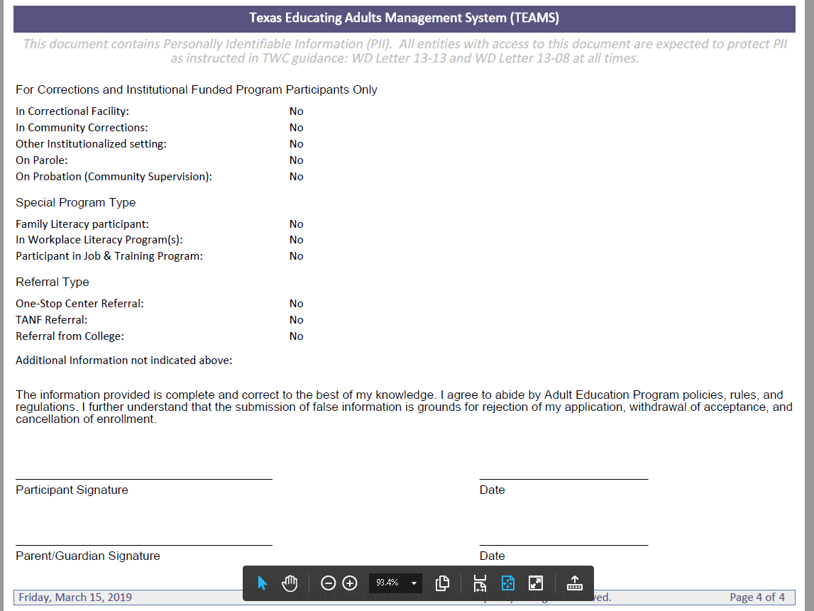

##### Image 2/2 - .XLSX Participant Profile

## 5. TxCHSE Match – Educational Enrollment

### Update Description

If a student profile includes a TxCHSE Match record or an Educational enrollment is attached, the profile cannot be removed or deleted.