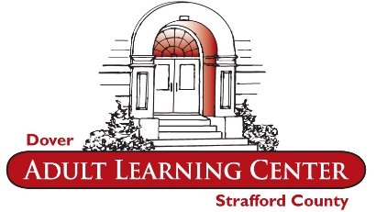
Dover Adult Learning Center
Laptop Loan Agreement

By participating in the Dover Adult Learning Center laptop loan program, your signature indicates that you as the borrower of the device agree to the following terms and conditions:
Eligibility
Students must be participating in a Dover Adult Learning Center course that requires the use of a computer for one of our trackable coursework systems. Students must receive a referral for the laptop loan program by their teacher or counselor.
Authorized Use
The borrower must present a photo ID and a $25 deposit at checkout, to be refunded to the borrower when the laptop is returned in good condition at the end of the loan period. Only the borrower is authorized to use the laptop (with charger) and borrower agrees not to lend, share or otherwise provide access to the laptop to any other person. The laptop is intended for academic use only. Any use of the laptop for other purposes is not authorized by Dover Adult Learning Center. The borrower must read and sign the DALC Policy and Guidelines for Computer Use.
Loss of Data
Dover Adult Learning Center is not responsible for the loss of any data, regardless of the cause. The borrower is strongly encouraged to use removable media such as a flash drive, or a cloud storage service to store work. All data on the laptop will be deleted upon its return.
Return
Borrower is responsible for the safe return of the laptop Dover Adult Learning Center on or before the return date listed on this agreement form. Dover Adult Learning Center reserves the right to require the return of the laptop at any time prior to the end of the term.
Financial Liability
If the laptop is not returned for any reason or if the laptop is returned with damage outside of normal wear and tear, borrower will be held financially responsible for the full cost of the laptop, which is $300.
Renewal
Participation in the Laptop Loan program for students is a privilege. Use of the laptop will be monitored online to insure that sufficient academic progress is being made. At the conclusion of the loan period, if the borrower wishes to continue their academic work with the laptop, a renewal may be requested. You must bring the laptop back to Dover Adult Learning Center by the return date to request renewal. There may be a waiting list for the laptop loan program, and loans/renewals are not guaranteed.
Dover Adult Learning Center
Laptop Loan Agreement

Dates of loan period:

Checkout: Return by:

Referred by:
(Teacher/Counselor)

For use in:
(Academic Coursework System)

Loaner Laptop Number:

I have read, understand and agree to be bound by the terms and conditions of the Dover Adult Learning Center laptop loan program:

Print full name:

Signature:

Date:

